The Update Widget

The Update folder must be placed in the directory

C:\Tcl\TideTool\

Open the update folder and create a shortcut to the Update_Tide_Tool.vbs file and move it to the desktop.

Before performing an Update, stop Tide Tool and any of the Map Clients that are running. The get_data.tcl process doesn’t need to be stopped unless it is being updated. Clicking the shortcut starts the Update widget:

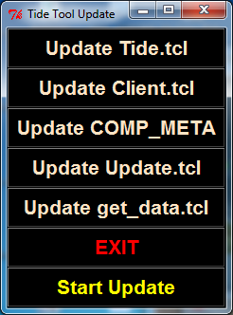

After the Tide Tool processes have been killed, you can start updating.

To update the software, click the button with the name of the file that is to be updated. It will turn green. In the example below, “Update COMP_META” was chosen:

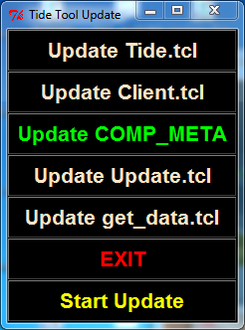

Click the “Start Update” button and the update will commence. The “Start Update” will change to “Update Starting”. When it is finished, that will change to “Update Finished”. At this point, the update(s) is complete. Click the “EXIT” button to quit the Update widget and then restart Tide Tool.