CRED REEF FISH DATA – OVERVIEW OF DATA GATHERING

## Pacific Reef Assessment and Monitoring Program (RAMP)

NOAA Coral Reef Ecosystems Division (CRED) surveys coral reefs at a total of ~40 islands and atolls in US and US-affiliated regions in the Pacific using consistent methods and survey design. The program, known as Pacific RAMP, is part of NOAA’s national coral reef monitoring program (NCRMP) (Brainard et al., 2014).

MARAMP, the Mariana Archipelago component of RAMP, began in 2003, and was initially conducted on a 2-year cycle, with a small team and relatively few surveys in each survey round. Beginning in 2009, the RAMP reef fish component was revamped, with the adoption of a stratified random sampling design within an explicit survey domain (<30m hardbottom), increased survey replication, and implementation of a new survey methodology. MARAMP surveys using this new approach were also conducted in 2011 and 2014. MARAMP is now on a 3-year cycle, with the next survey cruise planned for 2017.

## Reef Fish Surveys - Sampling Design and Monitoring Domain

CRED maintains GIS bathymetric and bottom composition maps for each island. The monitoring target habitat (<30m hardbottom) is stratified by reef zone (backreef, forereef, lagoon) and depth bin: shallow (0–6 m), mid (6–18 m), and deep (18–30 m). At some larger islands, the island is further stratified by section of coastline or management status. For example, Guam reef areas are classified as being “Marine Preserve”; “Guam Open East; and “Guam West”.

The locations of survey sites are selected using a formal randomization process, with a new set of sites selected prior to each survey mission. Typically, each island is visited for 3-5 days during a MARAMP cruise, which allows for a total of ~30-50 surveys to be conducted. Exceptions include the small islands of Sarigan, Guguan, and Alamagan, each of which is visited for one day. For routine analysis those three adjacent islands are pooled together into a single unit (“SGA”).

## Survey methods

Two types of data are collected at each survey site: fish counts; and benthic cover estimates.

### Counting and sizing reef fishes using the stationary point count method (SPC)

Each site is surveyed by a pair of divers conducting simultaneous counts in adjacent, visually estimated 15-m-diameter cylindrical plots extending from the substrate to the limits of vertical visibility (Figure 1). Prior to beginning each SPC-pair, a 30-m line is laid across the substratum. Markings at 7.5 m, 15 m and 22.5 m enable survey divers to locate the midpoint (7.5 m or 22.5 m) and two edges (0 m and 15 m; or 15 m and 30 m) of their survey plots. Each count consists of two components: (i) a 5-min **species enumeration period** in which the diver records the taxa of all species observed within their cylinder; followed by (ii) the **tallying portion** of the count, in which divers systematically work through their species lists, recording the number and estimated size (total length, TL, to the nearest cm) of each individual fish. The tallying portion is conducted as a series of rapid visual sweeps of the plot, with one species/grouping counted per sweep. To the extent possible, divers remain at the center of their cylinders throughout most of the count; but small, generally site-attached and semi-cryptic species are left to the end of the tally period, at which time the observer swims through their plot counting those species. When a species is observed during the enumeration period but is not present during the instantaneous sweep for that taxa, divers record size and number observed in the first encounter during the enumeration period and mark the data record as “non-instantaneous.” Surveys are not conducted if horizontal visibility is < 7.5 m.

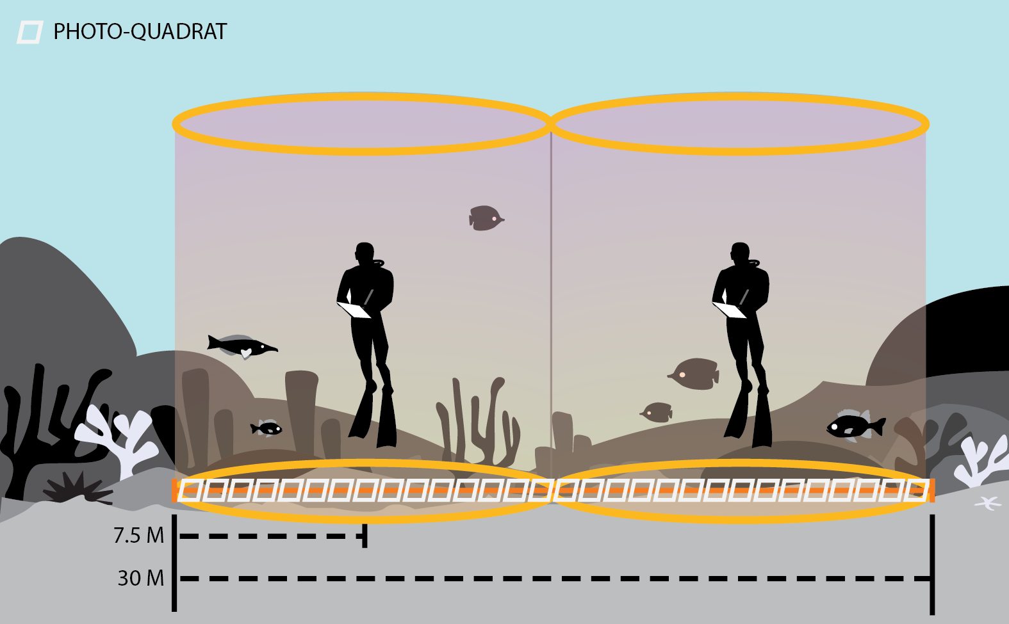

Figure 1 Side view of the stationary point count method. Surveys typically consist of one SPC-pair but some sites are surveyed by means of 2 SPC-pairs. During counts, dive partners count and size fishes within their cylinders measuring 7.5 m in radius. Once the fish survey is complete, divers estimate benthic habitat composition and conduct a benthic photo-transect spanning the two cylinders.

### Assessing benthic habitat characteristics

Two complementary methods are used to assess benthic composition within survey cylinders: (i) divers conduct **rapid visual assessments** of percentage cover of major functional categories (e.g. ‘coral’. ‘turf algae’, ‘macroalgae’); and (ii) divers conduct a **photo transect** through the middle of their SPC-pair. Analysis of photo-quadrat provides taxonomically finer-scale information, but requires post-survey processing and hence there is a lag before that data are available.

Divers also record reef habitat complexity by visually estimating the percentage of their cylinder that falls into the following levels of vertical relief: <0.20 m from substrate, 0.20–0.50 m, 0.50–1.00 m, 1.00–1.50 m, and >1.50 m. Divers also record the abundance of free (e.g., *Tripneustes, Heterocentrotus, Diadema* and *Echinothrix)* and boring (e.g., *Echinometra* and *Echinostephus*)urchins on a DACOR. Finally, divers also classify habitat type using the geomorphological categories identified by the NOAA National Ocean Service Biogeography Branch: aggregate reef, individual patch reef, aggregated patch reefs, spur and groove, pavement, pavement with sand channels, pavement with patch reefs, reef rubble, sand with scattered coral/rock and rock / boulder (Kendall & Poti, 2011).

More complete description of the survey approach are given in CRED fish survey standard operating procedure document (Ayotte, McCoy, Williams, & Zamzow, 2011).

## Synthesizing Data – Generating reef fish biomass estimates

Survey data are generally synthesized to generate estimates of biomass, i.e. weight of fish per unit area surveyed. Fish weights are derived from lengths using taxon-specific length-weight conversion parameters. To generate biomass (as g/m2), total fish weight is summed for a divers’ count and then divided by the area surveyed (176.7 m2 per SPC cylinder). Data from the two adjacent SPC cylinders are averaged to create a mean estimate for the SPC-pair. In some cases, a site is surveyed by means of 2 SPC-pairs. When that happens, data are averaged within the SPC-pairs, and then between SPC-pairs to generate site-level estimates. Fish data can be pooled in a variety of ways, e.g. per species, family or trophic group. The NCRMP default is to pool data by consumer group, i.e. as ‘PRIMARY’ (herbivores and detritivores); ‘SECONDARY’ (invertivores and omnivores); PLANKTIVORES; and PISCIVORES. Consumer group classifications are listed in CRED data reports (Heenan et al., 2014, 2015).

### Pooling survey data to strata and higher levels

Summary statistics (e.g., mean and variances) of survey quantities, e.g., biomass, are calculated from the surveys within each stratum. To pool those up into larger units (e.g. ‘island’), CRED typically uses the approach described by (Smith et al., 2011) which weights each stratum by its relative size (i.e., if a stratum is 50% of the total area in an island then is weighting factor will be 0.5, and total of all weighting factors sums to 1). Per strata mean and variance values are aggregated to higher level (eg to island scale) using the formulas below:

(1) pooled mean biomass (*X)* across S strata: $X= \sum_{1}^{S}{{(X}_{i}*w_{i}})$ and;

(2) pooled variance of mean biomass (*VAR)* across S strata: $VAR= \sum_{1}^{S}{{(VAR}_{i}* w_{i}^{2}})$

where *Xi* is the estimate of mean biomass within stratum *i*, *VARi* is the estimated variance of *Xi* and *wi* is the stratum-weighting factor.

## References

Ayotte, P. M., McCoy, K. S., Williams, I. D., & Zamzow, J. P. (2011). *Coral Reef Ecosystem Division standard operating procedures: data collection for Rapid Ecological Assessment fish surveys.* (Vol. Administra). Pacific Islands Fisheries Science Center PIFSC Admin Report 11-08. Retrieved from http://www.pifsc.noaa.gov/library/pubs/admin/PIFSC_Admin_Rep_11-08.pdf

Brainard, R., Caldow, C., Eakin, M., Gittings, S., Gledhill, D., Hill, R., … Williams, I. (2014). *NOAA Coral Reef Conservation Program. National Coral Reef Monitoring Program*. Silver Spring, MD. Retrieved from http://docs.lib.noaa.gov/noaa_documents/NOS/CRCP/noaa_crcp_national_coral_reef_monitoring_plan_2014.pdf

Heenan, A., Ayotte, P., Gray, A., Lino, K., McCoy, K., Zamzow, J., & Williams, I. D. (2014). *Pacific Reef Assessment and Monitoring Program - Data Report - Ecological Monitoring 2012-2013 - reef fishes and benthic habitats of the main Hawaiian Islands , American Samoa , and Pacific Remote Island Areas*.

Heenan, A., McCoy, K. S., Asher, J., Ayotte, P., Gorospe, K., Gray, A., … Williams, I. D. (2015). *Pacific Reef Assessment and Monitoring Program - Data Report - Ecological Monitoring 2014 - stationary point count surveys of the Northwestern Hawaiian Islands, Mariana Islands, and Wake Atoll*.

Kendall, M., & Poti, M. (2011). *A biogeographic assessment of the Samoan Archipelago*. *NOAA Tech Memo NOS NCCOS*. Silver Spring, MD.

Smith, S. G., Ault, J. S., Bohnsack, J. A., Harper, D. E., Luo, J. G., & McClellan, D. B. (2011). Multispecies survey design for assessing reef-fish stocks, spatially explicit management performance, and ecosystem condition. *Fisheries Research*, *109*(1), 25–41. doi:10.1016/j.fishres.2011.01.012

Williams, I. D., Richards, B. L., Sandin, S. A., Baum, J. K., Schroeder, R. E., Nadon, M. O., … Brainard, R. E. (2011). Differences in reef fish assemblages between populated and remote reefs spanning multiple archipelagos across the Central and Western Pacific. *Journal of Marine Biology*, *doi:10.115*, 14.

# Reef Fish Survey Data – Output Field Descriptions

|  |  |
| --- | --- |
| **DATA FIELD** | **DESCRIPTION** |
| SITEVISITID | A unique identifier for a site-survey |
| METHOD | Fish survey method used. Is always “nSPC” for data gathered using the current CRED stationary-point-count survey method |
| OBS_YEAR | The year in which the survey was conducted |
| REGION | Survey region – generally a spatially meaningful grouping, e.g. MHI are the populated Main Hawaiian Islands, NWHI are the unpopulated Northwestern Hawaiian Islands. For Mariana Archipelago islands, islands are grouped into “S.MARIAN” (the populated islands from Guam to Saipan), and “N.MARIAN” (the unpopulated or very lightly populated islands from Sarigan to Farallon de Pajaros) |
| ISLAND | The island where survey was conducted |
| SITE | A unique survey site code. First three letters are an island identifier, last 4 digits are a numeric value to make each SITE code unique to a particular survey location. |
| DATE_ | Date of the survey |
| REEF_ZONE | “Forereef", "Backreef' or "Lagoon" |
| DEPTH_BIN | Depth strata of the survey site: either Shallow (<6m); Mid (6-18m); or Deep (18-30m) |
| LATITUDE & LONGITUDE | Lat & Long of survey site, taken from the diving platform (small boat) above the divers. |
| DEPTH (m) | Mean site depth (in meters), recorded by divers during the survey. |
| HARD_CORAL  SOFT_CORAL  MA  CCA  TA | Benthic cover, visually estimated by divers during surveys. Categories are Hard Coral, Soft Coral, Macroalgae, Crustose Coralline Algae, and Turf Algae |
| PISCIVORE  PLANKTIVORE  PRIMARY  SECONDARY | Fish biomass (g/m2) by ‘consumer group’. PRIMARY are herbivores and detritivores; SECONDARY includes omnivores, and invertivores; PISCIVORES are fishes that feed primarily on fishes. Consumer groups are |
| TotFish | Total biomass (g/m2) of all fishes combined. |