# The Bathymetry of Kāne‘ohe Bay: Reflection of a Complex History

A project to collect high-resolution bathymetric (depth) data in Kāne‘ohe Bay was completed in October 2010, and the images and maps presented here provide an undersea view that dramatically reflects the long and complex history of this beautiful bay. Kāne‘ohe Bay is located on the southeastern and windward side of the island of O‘ahu and is the home of both the Marine Corps Base Hawai‘i and the University of Hawai‘i’s (UH) Hawai‘i Institute of Marine Biology (HIMB); the Bay is now mostly surrounded by heavily populated residential areas.

*This 3-D map of the seafloor in Kāne‘ohe Bay shows many effects of human activities over time.*

The first map of the Bay was produced during the U.S. Exploring Expedition to the Hawai‘ian Islands under Charles Wilkes in 1840 (Fitzpatrick, 1986); more detailed maps of Kailua and Kāne‘ohe were produced from the Lyons 1894-1896 survey and in 1902 by John Donn (Moffat and Fitzpatrick, 1995 and 2004).

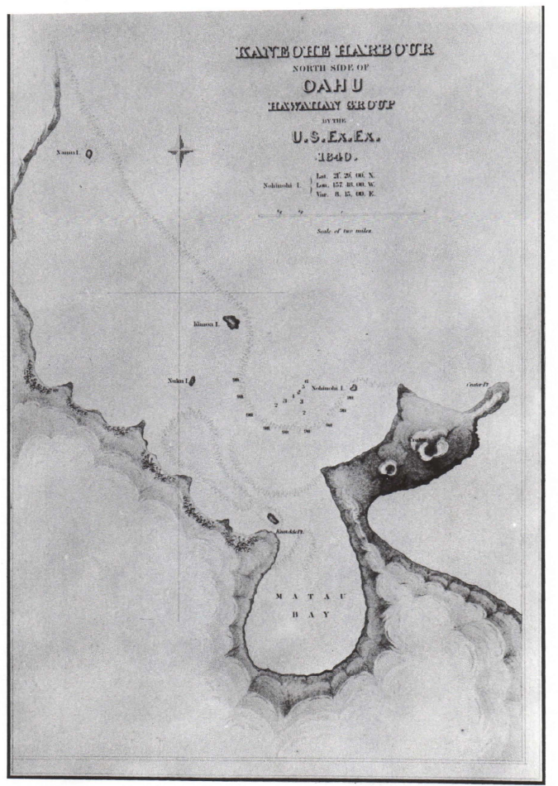

*First Map of Kaneohe Bay. 1840. U.S. Exploring Expedition. From Devaney et al., 1982.*

[*http://www.librarieshawaii.org/kaneohepl/kaneohehistory/kaneohe\_history\_of\_change\_ocr\_pt6\_pp113\_138.pdf*](http://www.librarieshawaii.org/kaneohepl/kaneohehistory/kaneohe_history_of_change_ocr_pt6_pp113_138.pdf)

Current nautical charts are based on surveys done between 1900 and 1939 (military surveys) and between 1970 and 1989 (NOAA Chart 19359). In 2000 and 2007, the U.S. Army Corps of Engineers performed Light Detection and Ranging (LiDAR) surveys around O‘ahu and in Kāne‘ohe Bay; however because of turbidity and resulting poor light penetration in Kāne‘ohe Bay, the LiDAR data in the inner part of the bay were only good to a few meters depth in many areas. A data synthesis for all [bathymetric data from the Main Hawai‘ian Islands](http://www.soest.hawaii.edu/hmrg/Multibeam/index.php) is available from the University of Hawai‘i’s (UH) Hawai‘i Mapping Research Group, but in 2010 there were also gaps offshore of Kaneohe Bay. To fill in the gaps in the inner bay from ~3-16 m water depths and in the UH synthesis, a sonar survey in and around Kāne‘ohe Bay was executed using the National Oceanic and Atmospheric Administration’s (NOAA’s) survey launch R/V *AHI* with a hull-mounted Reson 8101ER multibeam echosounder and a POS/MV vertical reference system. Thus for the first time, high-resolution bathymetry with almost complete bottom coverage is now available. Depths in the inner bay are generally 0-3 m (0-10’) on undredged coral patch reefs; 10 m (30-33’) in areas where coral was dredged; and 13-16 m (40-50’) in the deepest waters of the inner bay. Depths offshore drop quickly from the shallow coral to well over 2000 m (6000’) due to the steep scarps from the offshore landslides (Jokiel, unpublished).

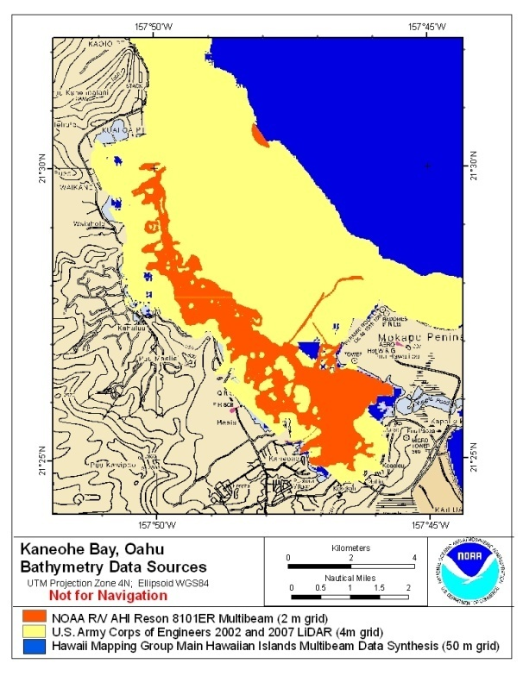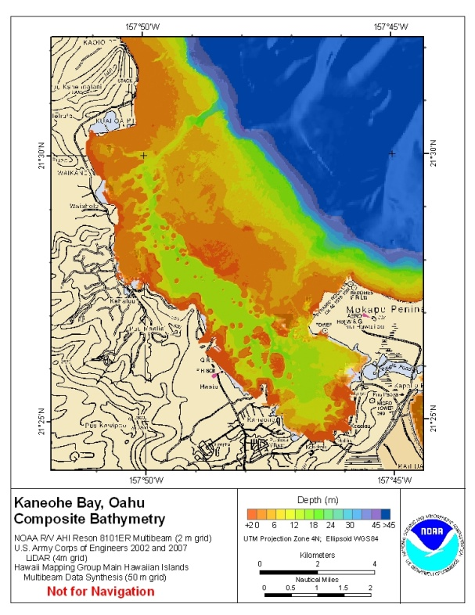

The bay lies on the east side of the Ko’olau Mountains in the area that was originally the volcano’s crater. Erosion and a massive earthquake that occurred about one million years ago caused the windward side of the Ko’olau volcano to break away; and the subsequent landslide, known as the Nu’uanu debris avalanche, carried a huge volume of rubble outward to a distance of 230 km from O‘ahu; these deposits are still quite prominent seafloor features east of O‘ahu. Late-stage eruptions in the Honolulu series of volcanics caused formation of 3 tuff/cinder cones on the Mōkapu Peninsula, as well as small islands in the bay and other better known features on O‘ahu (e.g., Diamond Head, Hanauma Bay) about 250,000 years ago. Sea level changes from +24 m to -120 m over the past 800,000 years have caused repeated sub-aerial exposure and re-flooding of Kāne‘ohe Bay, resulting in wave-cut terraces at depths of 55 and 91 m offshore ([Jokiel](http://cramp.wcc.hawaii.edu/Downloads/Publications/OD_JOKIELs_Scientific_Guide_to_K-Bay.pdf.), Fletcher et al., 2008).

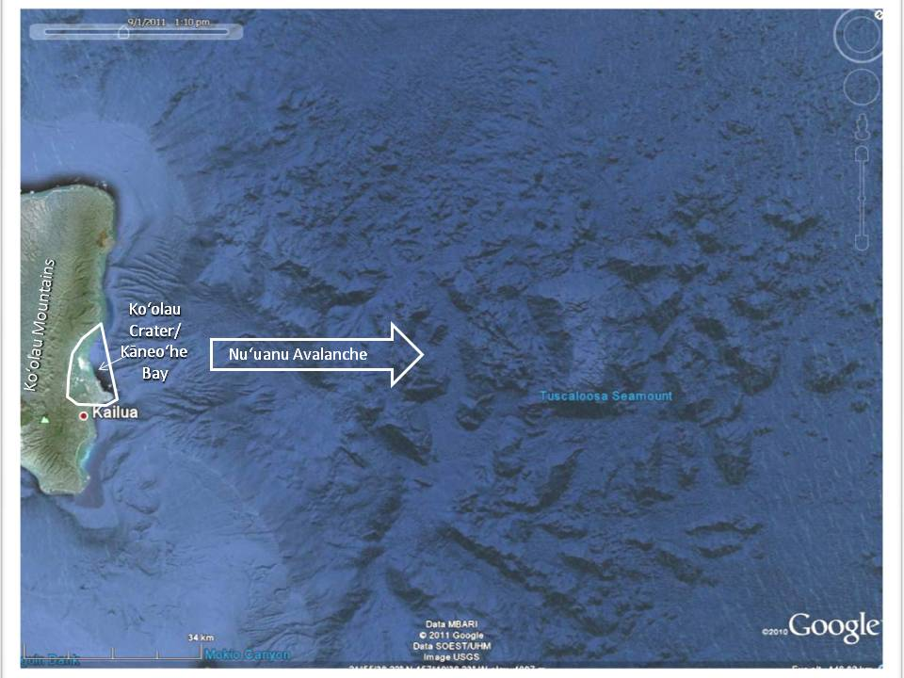

*Google Earth image of seafloor east of Kāne‘ohe Bay, which shows the steep drop-offs immediately offshore and the debris field from the Nu’uanu Avalanche, including the Tuscaloosa Seamount.*

Historically, Kāne‘ohe was part of the larger Ko‘olaupoko district (*moku*) that covered the southeast coast of O‘ahu from Kualoa to Waimānalo; Kāne‘ohe Bay and the surrounding 9 smaller Hawai‘ian land divisions (*ahupua’a* were land areas with boundaries that extended from the mountains to the sea) surrounding Kāne‘ohe Bay provided rich agricultural and fishing grounds (Devaney et al., 1982).

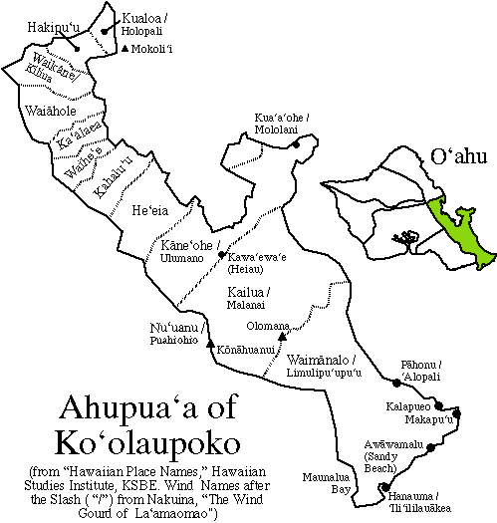

Figure from <http://apdl.kcc.hawaii.edu/~oahu/graphics/koolaupokoahupuaa.gif> (\*\*\*Redraw?)

Even after the “Great Mahele” (1845-1855), during which property rights were redistributed and land ownership became possible for both Hawai‘ians and non-Hawai‘ians, fisheries outside of the reefs were declared to be common property of everyone, while maintaining the ahupua’a boundaries between the reefs and the land. Until the mid-1800’s fishponds were critical sources of nutrition and it is estimated that there were as many as 30 fishponds were located in Kāne‘ohe Bay, though in 2011 there are only a few left. Ancient Hawai‘ian agriculture was coupled with fishing and fishpond aquaculture with limited negative impact on the environment. With the introduction of non-Hawai‘ian agricultural techniques, including the construction of networks of irrigation ditches, plowing, farm animals, deforestation, and erosion, a large volume of sediment has been deposited in Kāne‘ohe Bay ([Jokiel](http://cramp.wcc.hawaii.edu/Downloads/Publications/OD_JOKIELs_Scientific_Guide_to_K-Bay.pdf.)). Agricultural activities around the Bay have included taro (pre-European contact to 1940’s), sugarcane (pre-European contact to early 1900’s), rice (1860 to 1920’s), pineapple (early 1800’s to 1925), and cattle grazing (1840’s to 1970’s) (Devaney et al., 1982). The introduction of mangroves in 1921 has had both negative (outcompeting native plants) and positive (sediment trapping) effects on the environment ([Jokiel](http://cramp.wcc.hawaii.edu/Downloads/Publications/OD_JOKIELs_Scientific_Guide_to_K-Bay.pdf.)).

In the 1700’s Ko‘olaupoko was one of the most populated areas of O‘ahu, with an estimated population between 14,000 and 25,000. Population steadily dropped in the 1800’s due to disease and movement to Honolulu to a low of slightly more than 2000 persons in 1872 and peaked in the 1970’s and 1980’s at over 90,000 with half of this number (~46,000) in the 9 ahupua’a around Kāne‘ohe Bay (Devaney et al., 1982); current population around Kāne‘ohe Bay has been stable at approximately 34,000 since 2000 with a slight decrease anticipated in the 2010 census data according to the Hawai‘i Dept. of Economic Development and Tourism (link: [http://Hawai‘i.gov/dbedt/info/economic/databook/2009-individual/01/011509.pdf](http://hawaii.gov/dbedt/info/economic/databook/2009-individual/01/011509.pdf).)

Military activities around Mōkapu Peninsula began in 1918 and have continued since that time. On December 7, 1941, Kāne‘ohe Air Station was attacked 9 minutes before Pearl Harbor. During WWII the physical size of the base was doubled using dredged materials to provide landing facilities for military aircraft operations, and a radio listening station was located west of the air base near the Kāne‘ohe shoreline (shown on the previously classified Navy nautical chart); the foundations of this station are still evident in the bay. A 10-m-deep channel was cleared along the length of the Bay to allow ship access and a seaplane landing area was cleared in the southern bay, which was closed to surface craft during the war; thus the tops of numerous coral patch reefs throughout the bay were cut off to 10 m (~33’).

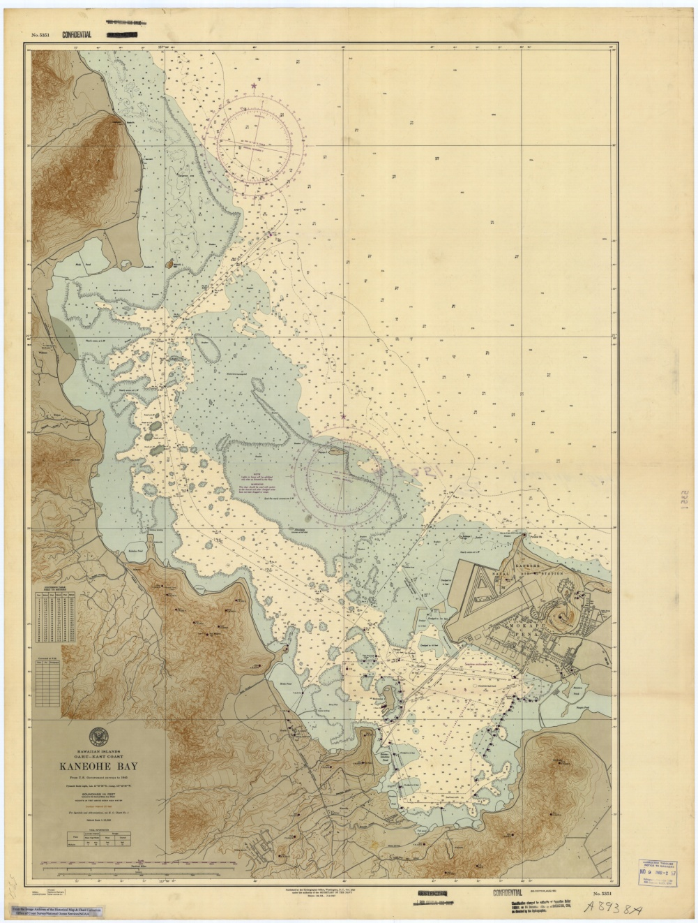

*WWII Chart of Kaneohe Bay (1947) that was originally classified.*

Prior to 1939 dredging had been limited to boat basins and piers that sometimes extended hundreds of meters over coral reefs, but much more extensive dredging, filling and spoil dumping were carried out as part of both military and private activities in the 1940’s through the 1970’s. Moku o Lo‘e (Coconut Island), now the home of HIMB, was originally owned by Hawai‘ian royalty but sold to a succession of private owners between 1933 and 1995, when it was purchased by the State of Hawai‘i for HIMB. Under private ownership this island was also enlarged using dredged materials. The fascinating story of this island, its owners, and many famous visitors is captured in a recent book “Moku o Lo’e: A History of Coconut Island (Klieger, 2007).

sat_sandbar_bright.tif

*The Sand Bar (right) and He‘eia Kea Marine (lower left). Recreational boating is a popular activity on northern Kāne‘ohe Bay.*

During the 1960’s and 70’s as a result of construction of the Pali and Likelike highways, which provided easy access to Honolulu, the population of Kāne‘ohe and the windward side increased dramatically. Construction of numerous houses and condominium complexes along the shores of the bay caused extensive erosion and further sedimentation in the bay with red rivers of dirt running into the bay after heavy rains. In addition to the construction-associated sedimentation, treated sewage flowed directly into the innermost southern part of the Bay. As a result the coral population of Kāne‘ohe Bay decreased dramatically while algae flourished Maragos, 1972; Maragos, and Chave, 1973). In 1978, as a result of local environmental activism, sewage dumping in the Bay was discontinued. The good news is that the coral reef ecosystems have made somewhat of a comeback since that time (Smith et al., 1981; Pastorok and Billiard, 1985). However, an alien alga with extremely high growth rates, *Gracilaria salicornia* (“Gorilla ogo”)*,* from the western Pacific was introduced into Kāne‘ohe Bay in 1974 as a potential commercial species. Unfortunately, this alga has developed into a continuing serious invasive threat that has been smothering the coral reefs. Joint efforts by HIMB, the Hawaii Dept. of Land and Natural Resources (DLNR), and The Nature Conservancy (TNC) using a device called “The Super Sucker”, which sucks the algae off of the reef, and introduction of native sea urchins to control the alga have shown positive results over the past decade (Norris, 2007). In addition to these threats, climate change is causing temperature increases and ocean acidification that severely threaten the coral reefs of not just Kāne‘ohe Bay or Hawaii, but the entire world (Hoegh-Guldberg et al., 2007). Hawai‘i scientists at HIMB, UH, DLNR, TNC, NOAA, ACOE and many other agencies are providing information, such as these maps, to help understand, assess and, hopefully, mitigate damage to our coral reef ecosystems.

References:

Devaney, D.M., Kelly, MM. Lee, P.J., Motteler, L.S., 1982. Kāne‘ohe: A History of Change. The Bess Press, 271 pp.

Fitzpatrick, G.L. with Moffat, R.M., 1986. Palpala‘āina: The Early Mapping of Hawaii. Editions Limited. 160 pp.

Fletcher, C.H., Bochicchio, C., Conger, C.L., Engles, M.S., Feirstein, E.J., Frazer, N., Glenn, C.R., Grigg, R.W., Grossman, E.E., Hrney, J.N., Isoun, E. Murray-Wallace, C.V., Rooney, J.J., Rubin, K.H., Sherman, C.E. Vitousek, S., 2008. Geology of Hawaii Reefs in Coral Reefs of the USA, Riegl, B.M., Dodge, R.E., eds., pp. 435-488.

[Hoegh-Guldberg, O., Mumby, P.J., Hooten, A.J., Steneck, R.S., Greenfield, P., Gomez, E., Harvell, C.D., Sale, P.F., Edwards, A.J., Caldeira, K., Knowlton, N., Eakin, C.M., Iglesias-Prieto, R., Muthinga, N. Bradbury, R.H., Dubi, A., and Hatziolos, M.E., 2007. Coral Reefs Under Rapid Climate Change and Ocean Acidification. Science 14, Vol. 318, no. 5857, pp. 1737-1742.](http://www.sciencemag.org/content/318/5857/1737.short)

Jokiel, P. (Date?) Jokiel’s Illustrated Scientific Guide to Kāne‘ohe Bay, O‘ahu. On-Line at <http://cramp.wcc.hawaii.edu/Downloads/Publications/OD_JOKIELs_Scientific_Guide_to_K-Bay.pdf>.

Klieger, P.C., with Helfrich, P. and Leong, J., 2007. Moku o Lo‘e: A History of Coconut Island. Bishop Museum Press, 280 pp.

Maragos, J.E., 1972. A study of the ecology of Hawai’ian reef corals, PhD. Thesis, University of Hawai’I, Honolulu.

Maragos, J.E., Chave, K.E., 1973. Stress and interference of man in the bay. In Smith, S.V., Chave, K.E., Kam, D.T.O. (ed.) Atlas Kāneo’he Bay: a reef ecosystem under stress. University of Hawai’i Sea Grant Program, Honolulu, Hawai’I, p. 119-123.

Moffat, R.M., Fitzpatrick, G.L., 1995. Palpala‘āina: Surveying the Mahele. Editions Limited, 120 pp.

Moffat, R.M., Fitzpatrick, G.L., 2004. Palpala‘āina: Mapping the Lands and Waters of Hawaii. Editions Limited. 120 pp.

Norris, S. 2007. “Super Suckers Slurp Invasive Algae Off Reefs”, National Geographic News.

Pastorok, R.A., Bilyard, G.R. 1985. Effects of sewage pollution on coral-reef communities. Marine Ecolosy, Vol. 21:175-189.

Smith, S.V., Simmerer, W.J., Laws, E.A., Brock, R.E., Walsh, T.W. 1981. Kāneo‘he Bay sewage diversion experiment: Perspectives on ecosystem responses to nutritional perturbation. Pacific Sciences, 35: 279-302.