**Procedure for Manual Configuration of Sensor Calibrations Auto Update Settings**

***Already set to auto update twice, daily. No other configuration is needed unless you want to change update interval or file location changes. File location set to OTG dropbox public folder.

1. Go to webpage:

<http://www.soest.hawaii.edu/UMC/cms/wp-admin/admin.php?page=tablepress_import>

1. Enter Login Information:
   1. Username: otg01
   2. Password: otg_km!!
2. You should now see this screen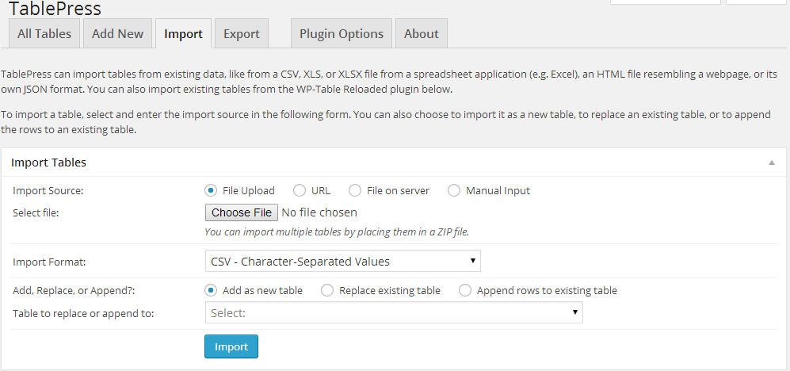
3. Scroll down to “Auto Import Tables” Section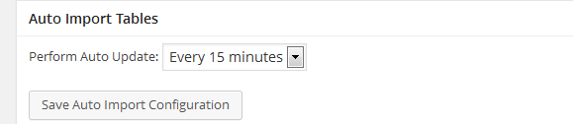
4. Pick update interval:

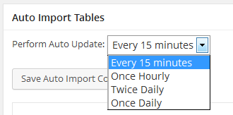

1. Scroll down to item “25” and make sure options are as follows:

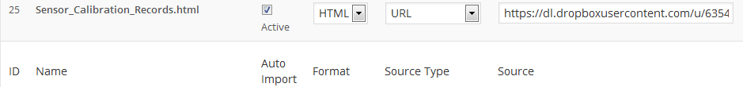

* 1. Active
  2. HTML
  3. URL
  4. Source: <https://dl.dropboxusercontent.com/u/63541682/Calibration_Docs/Sensor_Calibration_Records.html>

1. Make sure to press the “Save Auto Import Configuration” Button

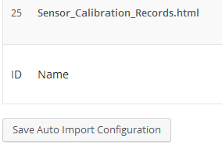

1. Done

Last updated: 4-07-2014