**Procedure for Manually Updating UHMO Sensor Calibration Webpage**

1. Go to webpage:

<http://www.soest.hawaii.edu/UMC/cms/wp-admin/admin.php?page=tablepress_import>

1. Enter Login Information:
   1. Username: otg01
   2. Password: otg_km!!
2. You should now see this screen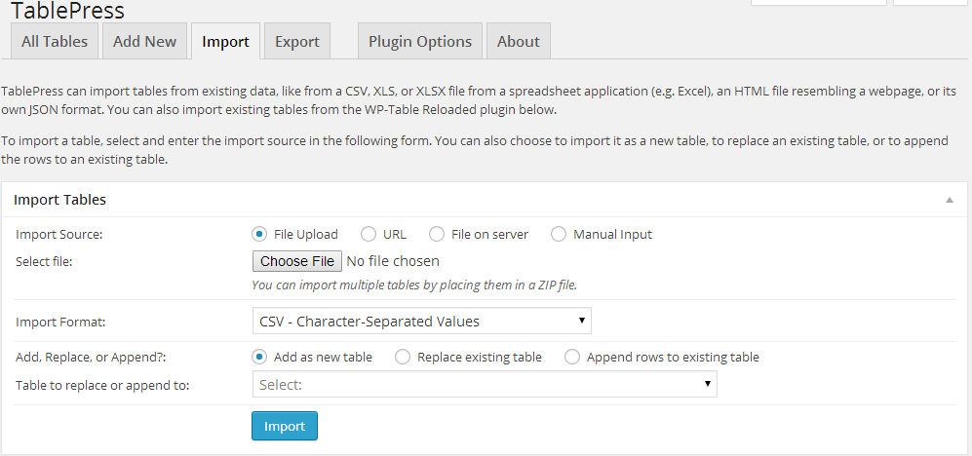
3. Select the updated “Sensor_Calibration_Records.html” file from the OTG dropbox folder: C:\Users\Ocean Technology Grp\Dropbox\Public\Calibration_Docs
4. Once the updated sensor calibration record has been chosen, the import format will automatically change to the correct format.
5. To finish updating, make sure the following options are as follows and press the import button.

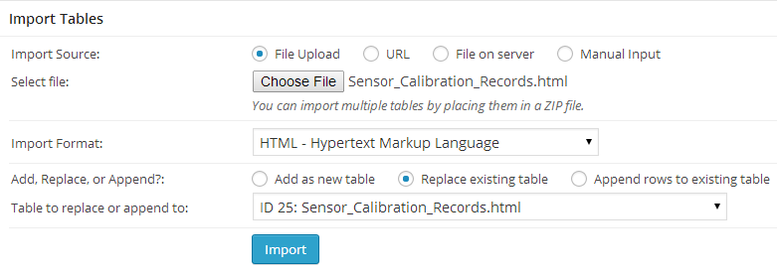

1. If everything was correct you should be brought to the updated table and see the following message:

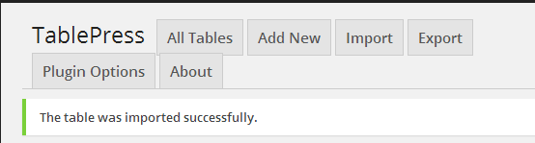

1. To make sure the table appears right away, hit the clear cache button in the top right corner of the screen:

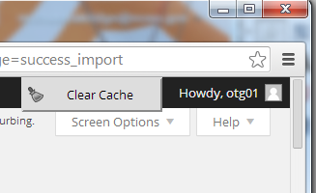

1. Navigate to the Sensor Calibration Records webpage and see if everything is correct. Link: <http://www.soest.hawaii.edu/UMC/cms/sensor-calibration-records/>
2. If so, then you’re done.

Last updated: 3-17-2014