ALOHA Backbone Communications Transport

Introduction
The ALOHA Backbone Communications Transport is comprised of a) Makaha terminal, repeatered line and Station ALOHA equipment required to transport 100 Mb/s Ethernet; and, b) Makaha terminal, regenerated line and Station ALOHA equipment to maintain the repeatered link. A very cost-effective method of carrying 100 Mb/s Ethernet serial data stream over a portion of the existing HAW-4 SL280 dry and wet plant has been implemented. This approach was presented at the SSC’06 Conference held in Feb, 2006 (Attachment A: Format and Bit-Rate Independent Communications over Regenerated Undersea Fiber Optic Cable Systems).

Development
The HAW-4 System contains (3) physically paired regenerators (some shared electronics) in each repeater with all inter-regenerator connections being soldered. Since we only required one regenerator at Station ALOHA and since the SL280 paired regenerator can not easily be separated, SL560 regenerator (exactly twice the bit rate) is being used instead. The main advantage is that the SL560 regenerator is completely self- contained, the interfaces use connectorized, and it easily mount in a pressure vessel. That then left the following questions to be answered:

- How well does a SL280 signal perform over a system containing one or more SL560 regenerators?
- How well does the user serial data stream perform? And,
- What are the effects on line supervision?

SL280/560 Signal Interoperability
SL280/560 signal interoperability was verified in August 2005 (in New Jersey) by using the SL280 Terminal Transmission Equipment (TTE) with a SL560 regenerator (the SL280 TTE contains transmit and receive regenerators made from the same components that are used in SL280 line regenerators). Error free transmission has been proven to be independent of the pseudo-random bit sequence used (maximum test set word length of 2^23-1) for the optical input signal level expected to be seen at Station ALOHA with at least 6 dB of margin to a 10-9 bit error rate. The SL560 regenerator clock recovery circuit thus works very well with the weaker 4th harmonic (591.2 MHz) of the SL280 signal. Identical equipment has also been in operation in Hawaii (UH at Manoa) since 1Q06.

User Serial Data Stream Performance
The user serial data stream performance testing over a 10-210 Mb/s range was initially completed in New Jersey by December 2005 and reported in February 2006 (see Attachment 1). The user data modulation approach actually results in a higher regenerator recovered clock signal amplitude than a standard SL280 or SL560 signal which has the primary effect of reducing the probability of jitter related line errors. Given that the original HAW-4 system error performance with 60 repeaters was usually better than 10^-13, error performance with 4 repeaters can only improve. End user testing has been ongoing in Hawaii since 1Q06 at the Proof Module data rate of 12 Mb/s and the Observatory data rate of 100 Mb/s.

Line Supervision
Line Supervision of the SL280 portion of the system is unaffected. While supervision of the SL560 regenerator at Station ALOHA is not necessary for initial deployment, the capability is required if we needed to switch to the spare laser (a laser failure is very unlikely based on the historical performance of both SL280 and SL560 systems); and, the regenerator signal switching functions can also helpful in isolating a fault between the node communication module and the actual Observatory. It is possible to easily provide a bit pattern at the Makaha TTE that is simultaneously line parity correct for SL280 and SL560 regenerators (both use 24B/1P line parity and line maintenance signaling via the parity bit); however, while a parity bit inversion is properly detected by the SL280 regenerator, that same parity bit inversion is seen as an adjacent data and parity bit inversion which is no inversion at all. We are presently taking the more straightforward approach of modifying the SL560 regenerator to run at the SL280 clock frequency by immediately dividing down the SL560 clock frequency at the output of the clock recovery circuit. Testing should be complete in the October 2006 timeframe.

Implementation Documentation
Figures 1, 2, 3 and 4 depict System, Makaha Terminal, Makaha TTE and the Station ALOHA Communications Module. This information was previously provided in the proposal/reviews and is included here for completeness.

Figure 1: ALOHA Cabled Observatory System

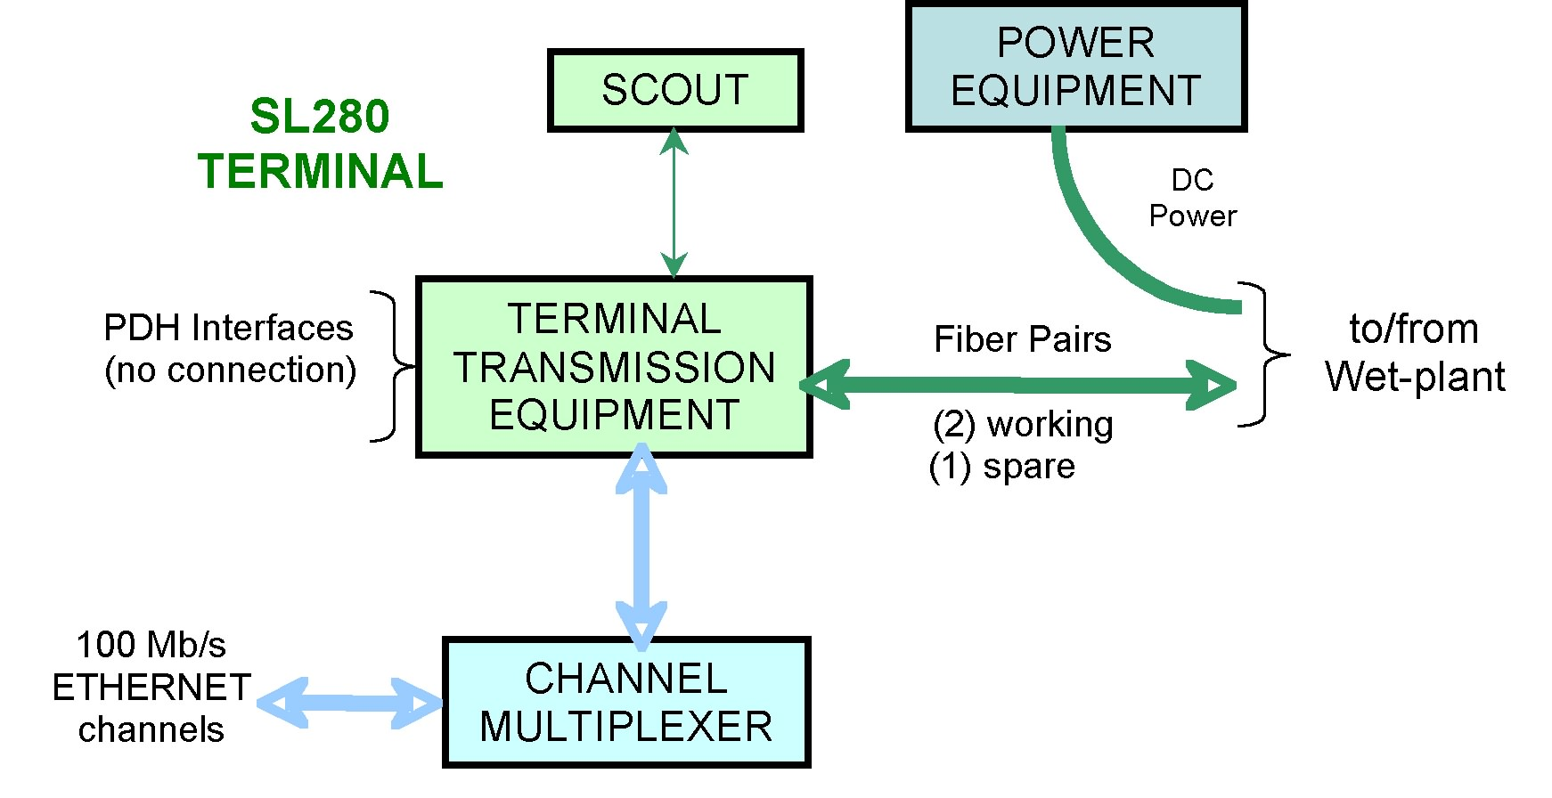

Figure 2: Makaha Terminal

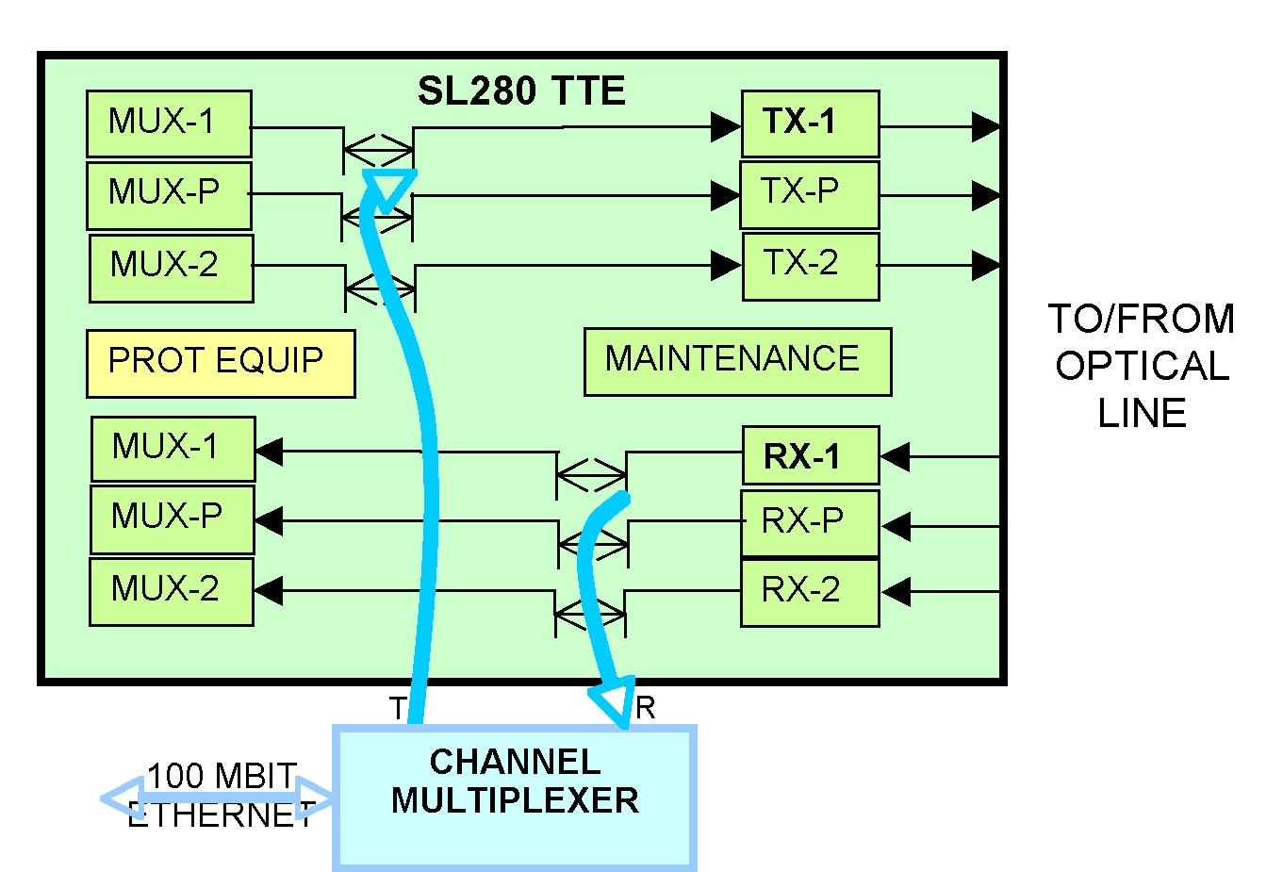

Figure 3: Makaha TTE/Channel Multiplex

Figure 4: Station ALOHA Regenerator/Channel Multiplex

The only physical modification to the SL280 TTE in Makaha is the replacement of the Voice Order Wire Shelf (previously used for cable station to cable station maintenance voice communications) with the Channel Muldex Shelf providing easy access to power and connection points. Figure 5 shows the Channel Muldex Shelf functional signal interconnections (refer to Attachment B for the entire Muldex Shelf schematic). The Muldex Shelf will initially be equipped with one Muldex board (MULDEX-1) connected to Line Pair 1; the second Muldex board can easily be equipped for Line Pair 2 should the need arise in the future. The Muldex boards can also be replaced with dual Ethernet channel versions in the future to double the data transport capacity. Muldex interconnects P12-( ) and P14-( ) are either connected to the SL280 TTE as shown in Figure 3 for normal Observatory communications or not connected for supervisory communications to the Station ALOHA regenerator shown in Figure 4 (line supervisory activity to all other repeaters can be performed at any time via the second and/or third unused line pairs).

Figure 5: Muldex Shelf Signal Interconnections
The Communications Module interconnections are shown in Figure 6 (refer to Attachment C for the entire Communications Module schematic). An identical Muldex board as that used in the terminal is connected to the SL560 regenerator. Normal ALOHA system operation is with the transmit Muldex signal applied to the regenerator J5/D11 port being selected for transmission back to the terminal. The Muldex signal can be bypassed using line supervisory commands for maintenance activities (there is a very low expectation that such maintenance activities will be necessary other than testing during initial deployment). As is being done in the terminal application, the Muldex at Station ALOHA will support one user channel; two user channels can be supported by replacing the Muldex.

The multiplexer portion of the Muldex itself is shown in Figure 7 (refer to Attachment D for the entire schematic). The exclusive-ORing (IC4) of the data and half-rate line clock is the key, as indicated in Attachment A, to providing a bit rate and format independent user channel over the SL280 line (or SL560). Everything else in the Muldex is for external signal interface and data re-clocking. The half/quarter clock jumper selection TJ1/TJ2 to TJ3 will no longer be necessary (as will IC3) when we complete the modification to the regenerator for running at the SL280 clock rate (only TJ1 to TJ3 will be used). Going to two user channels will require an additional optical/electrical transceiver (TRCVR1 in the drawing) plus 2:1 multiplex device and will be implemented if the need arises.

Testing:
As indicated earlier, testing has been ongoing since August 2005. Testing activities with respect to the ALOHA Backbone Communications Transport are presently centered in the user channel area: that is, communications to/from the Proof Module and Observatory. All of the transport communications test are done using SL280 terminal and SL560 regenerator hardware. And, there is every expectation that the deployed backbone communications performance will be as good or better than that obtained over the HAW-4 system during its shorten usage lifetime.

Supervisory communications to the aforementioned clock-rate modified SL560 regenerator will commence shortly and also is not expected to show any surprises.

Figure 6: Station ALOHA Communications Module

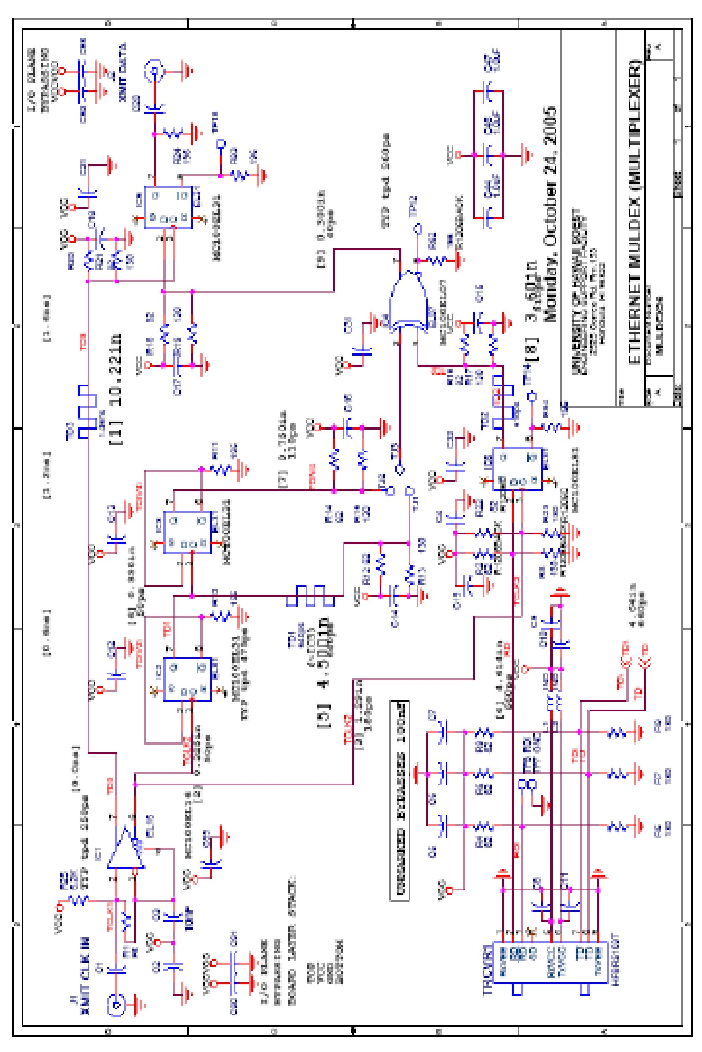

Figure 7: Multiplexer

