*Spring Semester 2023*

Small-Scale Air-Sea Interaction  
[OCN 665/ATMO665]

**Instructor**: Kelvin Richards (rkelvin@hawaii.edu; x65399)

**Do you want to understand these physical processes   
and how they contribute to weather and climate?**

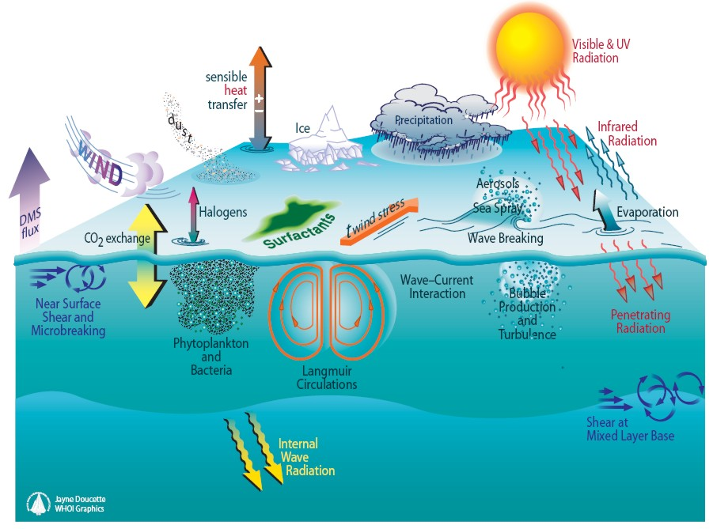

This course will introduce oceanography and atmospheric science students to processes in the lower atmosphere and upper ocean that contribute to the transport of heat, momentum and other properties, and their transfer between the two media. Such processes underlie the coupling between the ocean and atmosphere. Topics covered include: theories of turbulent boundary layers, the physics and thermodynamics of planetary boundary layers, ways to observe the lower atmosphere and upper ocean, the role of surface and internal waves and the Earth’s rotation, the impact of lateral variability such as fronts.

Prerequisites: OCN 620 or ATMO 600 (with a passing grade); or consent of instructor.

**Syllabus**

**Topics covered**

1. Motivation
2. Basic Physics
3. Turbulence
4. Boundary Layer Theory
5. Waves on the Interface
6. Atmospheric Mixed Layer
7. Ocean Mixed Layer
8. Gas Transfers
9. Deep Convection
10. Storms
11. Ocean Fronts

**Grading:**

Term paper 50%

Contribution + Homework 50%