**Climate Change in the Federated States of Micronesia**

*Dr. Charles Fletcher (University of Hawai‘i)*

*Dr. Art Sussman (WestEd)*

**Pacific Islands Climate Education Partnership LOGO**

You may have heard the term **climate change**. What does this term mean? In what ways is the climate changing? How does climate change affect the Federated States of Micronesia? The purpose of this booklet is to answer these questions.

**What are weather and climate?**

To learn about climate change we need to understand the difference between weather and climate. **Weather** is the short-term condition of the atmosphere in a specific place, such as where you live. Is it raining today? Where is the wind blowing from and how strong is it blowing? Is the air hot or cool? How cloudy is the sky?

**Climate** is the long-term average weather pattern in a specific place or larger area. When scientists describe the climate in a place, they use measurements and observations of the weather that have been made over periods of 30 years or even longer. The climate in a place has very big effects on the plants, animals and people who live in that place.

The Federates States of Micronesia have a climate where the weather does not change that much over the course of a year. Other places on our planet have climates where the weather changes a lot over the course of a year. For example, many places have very cold snowy winters, and very hot summers (see **Figure 1**).

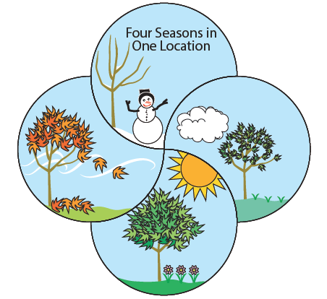

**Figure 1** *Many locations on our planet have four seasons, such as a very cold winter (top), a warmer spring (right), a hot summer (bottom), and a cooler fall (left) when leaves change color and fall off the trees.*

Keep as is

Climate describes what kind of weather you can expect to happen. Weather describes what is actually happening. If you visit a place in the winter that has a climate with very cold winters, you should expect that it would be very cold. However, the week that you visit, the weather could actually be warm. It was probably cold the week before, and it will probably become cold again the week after you leave.

**What is the climate in the Federated States of Micronesia?**

**Warm with High Humidity**

The climate in the Federated States of Micronesia is generally warm and breezy with high humidity. The map (see **Figure 2**) shows two factors that play the biggest roles in causing this climate:

• The Federated States of Micronesia (FSM) is located near the equator

• FSM is surrounded by the ocean in all directions

Places near the equator get a lot more energy from the Sun than places that are farther away from the equator. This location is the main reason that the islands in FSM are warm. Air above warm ocean water is heated by that water, and also has a lot of water vapor in it making the air humid. The warm ocean around FSM helps keep the temperature warm at night, and makes the air feel warm and humid.

**Federated States of Micronesia in the Tropical Pacific**

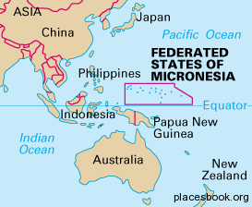**Figure 2** *The Federated States of Micronesia (FSM) is located in the western Pacific near the equator.*

Revise to match style of RMI Figure 2

**Wet and Dry Seasons with Variable Rainfall**

The weather and climate in Micronesia (**Figure 3**) have been observed and analyzed for centuries, and have been scientifically measured for decades. There are several patterns in addition to being generally warm and humid. One of the most important climate patterns is that there is a wet season and a dry season.

**Federates States of Micronesia – Yap, Chuuk, Pohnpei, and Kosrae**

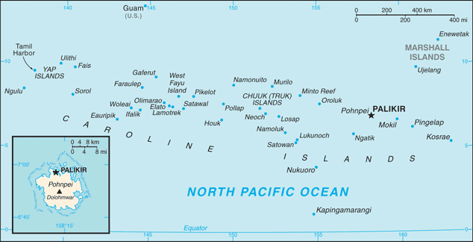

**Figure 3** *The Federated States of Micronesia are mostly located at latitudes between 5°North and 10°North.* Revise to match style of RMI Figure 3

The wet season is usually from May to October (summer), and the dry season from November to April (winter). **Figure 4** shows the annual rainfall measured in Pohnpei between the years 1950 and 2010. Note that the amount of rain changes a lot from year to year. Some years had 210 inches (533 cm) or more of rain, while other years had 150 inches (381 cm) or less of rain. This kind of change in rainfall from year to year is a natural feature of the climate in many Pacific islands that are near the equator. Scientists say that the amount of rainfall has a lot of **variability** (natural change from year to year).

**Pohnpei Annual Rainfall**

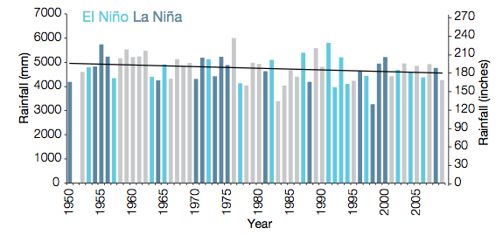

**Figure 4** *The amount of rainfall in Pohnpei has a lot of variability from one year to the next.*

Revise to match style of RMI Figure 4 – use only inches and put on left axis

The amount of rainfall in FSM can be very different from one year to the next. This is because of certain types of climate patterns that we discuss next: the Intertropical Convergence Zone and the El Niño Southern Oscillation.

**The Intertropical Convergence Zone Influences the Amount of Rain**

The winds near the equator usually blow from the east to the west. These winds are called **trade winds**. Near the equator, the trade winds in the northern hemisphere and trade winds in the southern hemisphere come together and cause a band of rain called the **Intertropical Convergence Zone** or ITCZ. This very cloudy and rainy area can be seen in satellite photos (**Figure 5**) as a band of thunderstorm clouds somewhat north of the equator.

**The Intertropical Convergence Zone is a band of clouds near the equator**

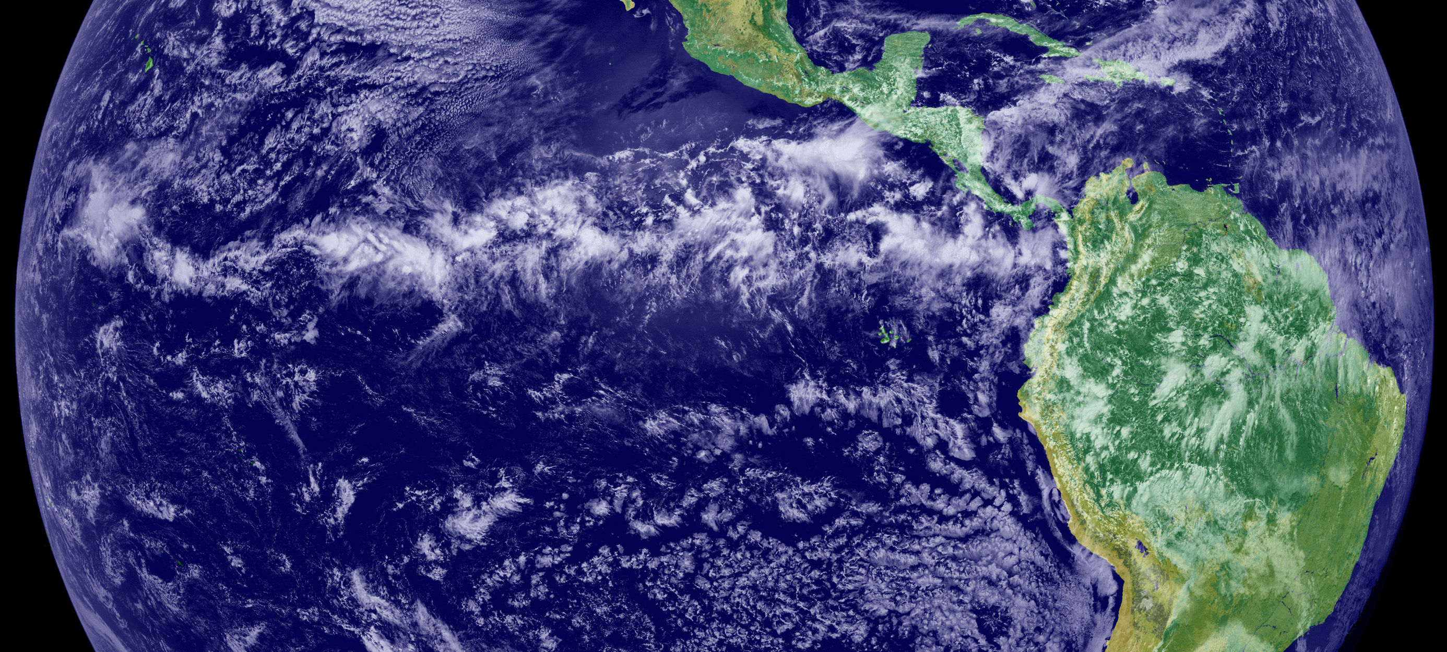

**Figure 5** *The strong sun and warm water of the equator heats the air and increases its humidity. The warm humid air rises and becomes colder as it gets higher in the atmosphere. As the rising air gets colder, the water vapor condenses and forms big clouds that release the water in thunderstorms.*

This long band of rainy area near the equator does not just stay in one place. The wet season occurs in the summer when the area of rain tends to move to the north closer to the FSM. The dry season occurs in the winter when the area of rain moves further south away from most of the islands in the FSM.

**Variable Trade Winds**

The trade winds that usually blow from east to west play a large role in the climate of the equatorial Pacific Ocean. These winds can change during a climate pattern that is called the **El Niño Southern Oscillation** or ENSO. When these winds are weaker than usual, scientists say that it is an El Niño year. When the winds are stronger than normal, scientists call it a La Niña year. When the trade winds are normal, it is called a neutral year.

In a neutral year (normal trade winds), the waters in Micronesia are much warmer than waters in the central or eastern portions of the Pacific Ocean. The warm water leads to strong evaporation and there is abundant rain (**Figure 6**).

In a La Niña year, strong trade winds blow across the ocean surface into Micronesia. This raises the level of the ocean and can cause coastal erosion, and damaging king tides. La Niña years also tend to be rainy in Micronesia.

In an El Niño year, the trade winds are weaker than normal (or absent). Warm ocean water from Micronesia surges into the central and eastern Pacific Ocean. This leads to a falling sea level and greater chance of drought in Micronesia.

**Conditions during neutral and El Niño Years**

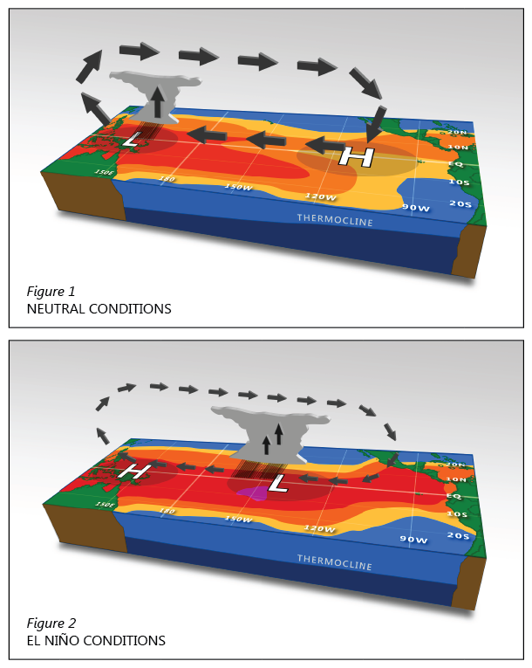

**Figure 6** In a neutral year the trade winds tend to be moderate, and in a La Niña year the winds tend to be strong. In both cases, the ocean water in Micronesia is warmer than in the central or eastern Pacific. During an El Niño year the trade winds are weak or absent. There is less rain than usual over Micronesia, and more rain than usual over the central or eastern Pacific.

Remove labels “thermocline” and grid and labels. Remove H and L and remove figure 1 and 2…make one box. Keep labels “Neutral conditions” and “El Niño conditions”. Remove arrows going up and down and in the sky – keep arrows at ground level. Add labels “Evaporation” to both clouds (keep upward arrows in clouds), add labels “Trade Winds” (to strong arrows) and “Weak Trade Winds” (to weak arrows), on the side of the panel add “Cold Water” to dark blue and “Warm Water” to light blue

**Table 1** summarizes the differences between neutral years, El Niño years, and La Niña years.

**Table 1** **ENSO Conditions and the Effects of ENSO Changes**

|  |  |  |  |
| --- | --- | --- | --- |
| **Feature** | **Neutral ENSO Year** | **El Niño ENSO Year** | **La Niña ENSO Year** |
| Wind | Normal east to west trade winds | Weaker east to west trade winds; can even blow from west to east | Stronger east to west trade winds |
| Rainfall | Usual amounts of rainfall with normal variability | Federated States of Micronesia tends to be drier than usual, and can have long droughts | Federated States of Micronesia tend to be wetter than usual |
| Sea Level | Usual sea level with normal tide variability | Lower sea levels so high tides tend to cause less flooding | Higher sea levels so high tides tend to cause more flooding |

**Extreme Weather Events**

Extreme weather events are another important climate feature. An extreme weather event is the kind of weather that can cause a lot of damage and problems for ecosystems and people. The main extreme weather events that happen in the FSM are droughts and big storms.

Droughts typically occur in the months of January to June, especially in the year following an El Niño. During particularly strong El Niño drought, the rainfall can decrease by as much as 80%.

Very strong storms in the equatorial Pacific Ocean region are called **tropical cyclones**. These storms typically happen between August and November and they have strong, damaging wind and very heavy rainfall.

During La Niña conditions tropical cyclones tend to form to the north and west of Micronesia. During El Niño conditions tropical cyclones tend to form in Micronesia. For instance, tropical cyclones may form near Yap during a La Niña year, whereas during an El Niño year they may form in Kosrae State and the Marshall Islands. In years with strong El Niños, tropical cyclones may develop near Hawaii such as Super Typhoon Paka in 1997 and can travel thousands of miles to impact Micronesia.

**Table 2** summarizes the main features of the climate in FSM.

|  |
| --- |
| **Table 2**  **Summary of the main features of the climate in the Federated States of Micronesia:**   * Warm days and nights all year * Wet and dry seasons * Lots of variability in annual amounts of rain * Breezy with trade winds normally blowing east to west * Lots of variability in wind speed and wind direction * Extreme weather events: drought and tropical cyclones * Strong influence by climate conditions known as El Niño, La Niña and   the Intertropical Convergence Zone |

**What is happening to climate on our planet?**

Our planet has been around for a very long time (more than four billion years). During that time the climate of the planet has changed many times. Sometimes the climate has been very cold, with large amounts of ice covering most of the land and even large parts of the ocean. Sometimes the climate has been very warm when even the Polar Regions had little or no ice.

For the past 10,000 years, Earth’s climate has been very comfortable for people and for ecosystems. However, the climate is beginning to change because of human activities, especially our burning of fossil fuels (oil, coal and natural gas). Since our human activities are causing the global climate to become warmer, this change is often called **global warming**.

We use oil to make the fuel that provides the power for transportation (such as gasoline for cars, boats and trucks). People also burn fossil fuels to make electricity. When we burn oil and coal, the burning produces gases (especially carbon dioxide) that trap heat in the atmosphere. Other human activities are also producing gases that go into the atmosphere and trap heat (**Figure 7**). This trapping of heat in the atmosphere is causing Earth’s climate to get warmer.

**Pollution from Burning Fossil Fuels**

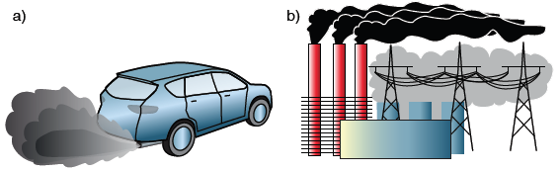

**Figure 7** *When we burn fossil fuels (oil, coal and natural gas), they produce gases that stay in the atmosphere and trap heat, causing global warming. a) Oil is used to make gasoline to run cars and trucks. b) Oil, coal and natural gas are burned to make electricity.*

The graph of average global temperature over the past 130 years shows that the global temperature has been increasing (**Figure 8**). The temperature data are collected from weather stations around the world and cover the period 1880 to now. There is a lot of variability from year to year. However, over all the years in the graph, there is a clear trend that Earth’s climate has been getting warmer. Global temperatures in the last ten years are significantly higher than they have been for any other ten-year period.

**Global Annual Temperature**

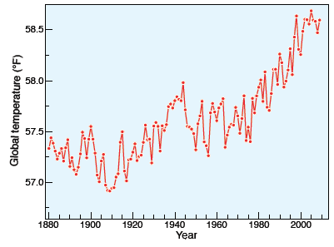

**Figure 8** *The annual average temperature of the air close to Earth’s surface.*

Over the past 100 years, Earth’s temperature has increased about 1.6 °F (0.9 °C). While this amount may not seem very much to us, it is actually a lot for planet Earth. A decrease in global temperature of about 10 °F (5.6 °C) can cause an Ice Age. In the geologic past when Earth’s average temperature was 10 °F higher, most of Earth’s ice was gone and sea levels were 100 feet higher.

The higher global temperatures cause many other changes to weather patterns and conditions on the planet. As a result, scientists tend to use the broader term *global climate change* to describe this issue, rather than global warming. These global climate changes include:

1. Glaciers everywhere in the world are melting.
2. Sea level is rising.
3. The oceans are getting warmer.
4. Ecosystems are moving away from current locations toward locations that are not as hot.
5. Spring is coming earlier in places that have four climate seasons.
6. More of the planet is having tropical climate.
7. Generally wet places are getting wetter (flooding) and dry places are getting dryer (drought).

These and many other observations show that Earth’s climate system is rapidly changing because of global warming. Global climate change affects the Federated States of Micronesia Islands in many ways. The rest of this booklet focuses on the changes that are already happening and the climate changes that are predicted to happen. We will also discuss what people in Micronesia can do to help protect themselves from the impacts (damaging effects) of climate change.

**What impacts of climate change are happening in the Federated States of Micronesia?**

As shown in **Figure 9**, the four most important impacts (damages) of global climate change on the FSM are:

* Higher air and ocean temperatures
* More drought
* Sea level rise
* Ocean acidification

Global warming means that **air and ocean temperatures are warmer**. These higher temperatures can directly harm ecosystems and human communities, and is itself an impact of climate change. For instance, warmer ocean water is an unhealthy condition for coral reefs and fish. In addition, these higher temperatures are causing one of the most serious climate impacts: sea-level rise.

Higher ocean temperatures cause the oceans to have a larger volume[1]. Thus, the ocean surface rises. This accounts for about 1/3 of the amount of global sea level rise. Higher air temperatures also cause mountain glaciers to melt, and this water flows into the ocean (accounting for another 1/3 of global sea level rise). The last 1/3 of global sea level rise comes from melting ice on Greenland and Antarctica. As a result of warming seawater and melting ice, oceans have a higher volume, and sea levels around the world are rising. This sea level rise is one of the most damaging impacts of climate change, especially for island communities.

Global warming also causes changes to rain patterns. For the FSM, the most damaging impact of changing rain patterns is that droughts will probably get more severe. They may happen more frequently and for longer periods of time.

**Ocean acidification** is another major impact caused by higher carbon dioxide levels. When carbon dioxide dissolves in the ocean, it forms a weak acid. As excess carbon dioxide in the atmosphere dissolves in the ocean, it changes the acid-base chemistry of the ocean, and causes it to become more acidic. Ocean acidification is included as a climate change impact because it is caused by the same increase in carbon dioxide that causes the other climate change impacts. Ocean acidification also harms many of the same marine ecosystems, especially coral reefs, plankton, and shellfish that are additionally harmed by higher ocean temperatures.

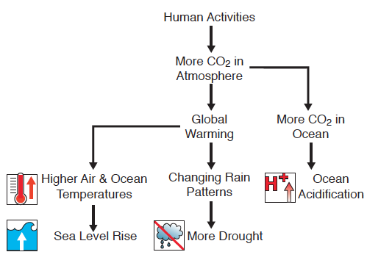

**Figure 9** *Human activities, mainly burning fossil fuels, are putting more heat-trapping gases, especially carbon dioxide, into the atmosphere. These activities are causing global warming. The four major impacts of climate change in Micronesia are shown with a graphic image next to each one.*

**How do these climate change impacts harm ecosystems and human systems in the Federated States of Micronesia?**

Many people think that humans should protect the natural world. All four of the climate change impacts shown in **Figure 9** (sea level rise, higher temperatures, drought, and ocean acidification) harm FSM ecosystems. These impacts harm the organisms that live there and the human communities that get many benefits from these ecosystems. These benefits include cultural and spiritual values, food, and income from fishing and tourism (**Figure 10**).

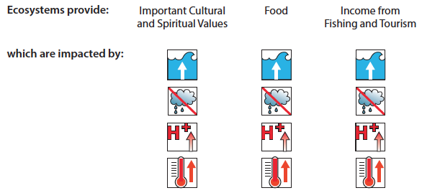

**Figure 10** *Sea level rise, drought, ocean acidification and higher temperatures all damage major services that are provided by ecosystems.*

In addition, climate changes harm the human systems that people depend upon for their homes, food, fresh water, and transportation (**Figure 11**).

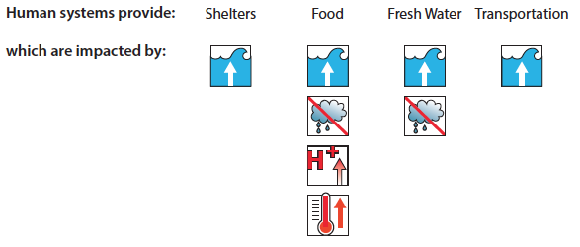

**Figure 11** *Climate change damages major services that are provided by human systems.*

Sea level rise is especially important since it harms essentially all Micronesian ecosystems and human systems. Since 1993, sea level rise has been occurring around the FSM at about 0.3 in/year (7 mm/year). Sea level rise causes beach erosion, flooding during high tide, and increased storm surge. Sea level is expected to continue rising, perhaps by more than 3 feet (1 meter) by the year 2100.

This increase in sea level means that anything that makes the ocean waves reach farther inland (such as a high tide or a large storm) will cause more flooding than when the sea level was lower. Higher sea level also causes more erosion of the coast. Higher sea level also affects the availability of food and water. When the ocean floods the land, the soil becomes salty, which damages the natural plants and trees, and also makes it much harder to grow food. The higher sea level can also reduce the amount and quality of the underground fresh water.

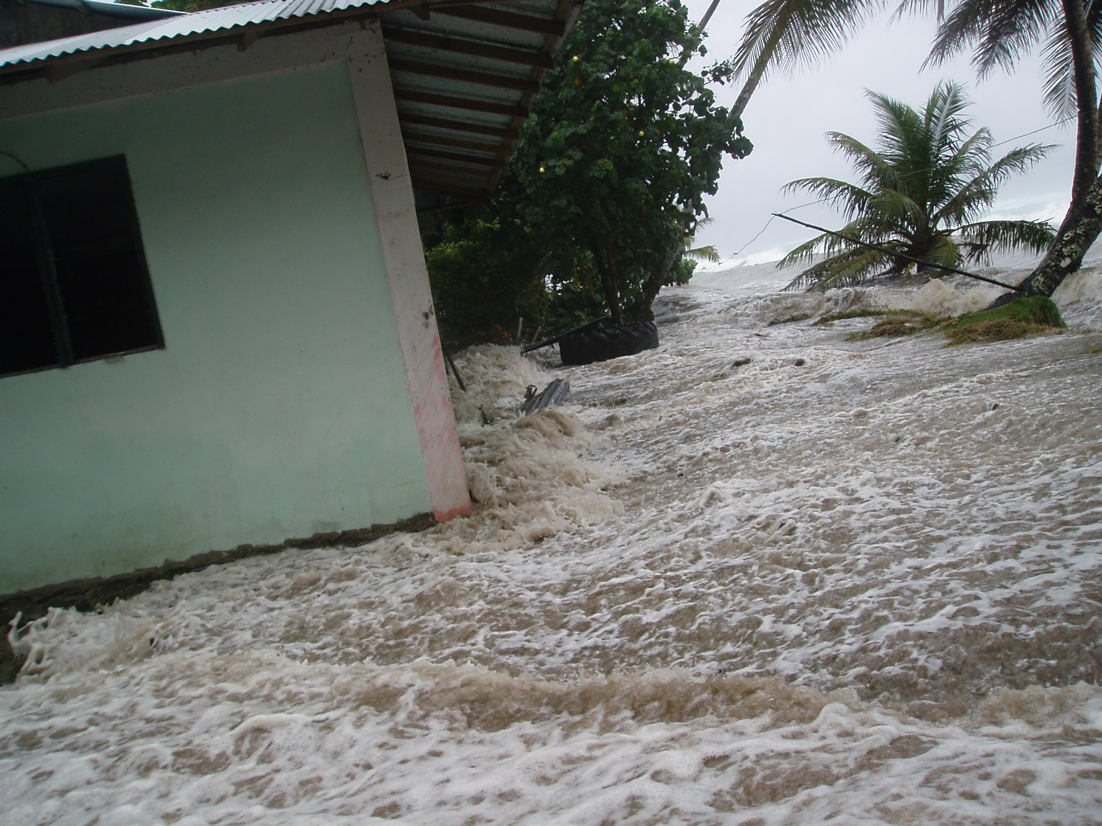For example, in December of 2008 serious flooding (**Figure 12**) occurred when there was no local storm. In that case it was the highest tide of the year happening with higher sea levels and large waves from a distant storm. Communities throughout FSM were flooded by waves and extreme high tides that eroded beaches, damaged roads, flooded freshwater aquifers and wetlands with saltwater, and inundated communities. Seawater surged up through the ground killing taro, breadfruit, and other food crops. Crop sites in use for generations were destroyed on approximately 60 percent of inhabited atoll islets. Food and drinking water were in short supply. A nationwide state of emergency was announced on December 30, 2008 and food security was declared the top priority in the nation.

**Figure 12** *During the highest tide period of the year in winter of 2008, ocean water washed across the road and into houses throughout the Federated States of Micronesia.*

Often the different impacts of climate change harm the same ecosystem or human system, and cause more damage than either would by itself. For example, higher ocean temperatures and ocean acidification both harm local marine ecosystems such as coral reefs (**Figure 13**). Coral are very sensitive to increases in temperature. Since the 1970’s the water has warmed about 0.8°C (1.4°F) across the entire nation of FSM. Warmer ocean water can lead to coral bleaching, and damage to local marine ecosystems and fishing.

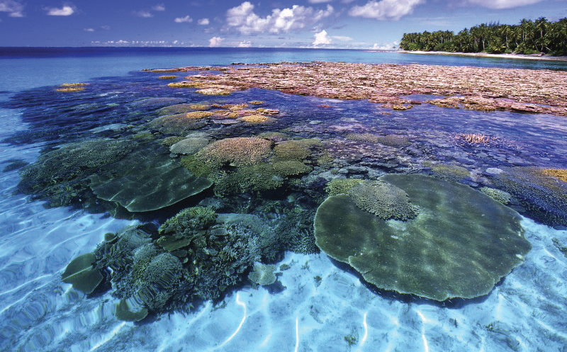**Figure 13** *Ocean acidification harms the coral, plankton, and other organisms that use calcium carbonate to make their shells and the reef. Higher ocean temperatures also damage coral reefs.*

The outside hard parts of many shelled organisms, such as plankton, and of the coral reef itself, are made of carbon combined with calcium and oxygen in a solid form called calcium carbonate. As the ocean becomes more acidic, it is much more difficult for many marine organisms to make and keep their hard calcium carbonate shells. Since plankton and coral are very important for marine ecosystems, this ocean acidification also can decrease the populations of many marine organisms that do not have shells. One quarter of all sea animals spend time in coral reef environments during their life cycle.

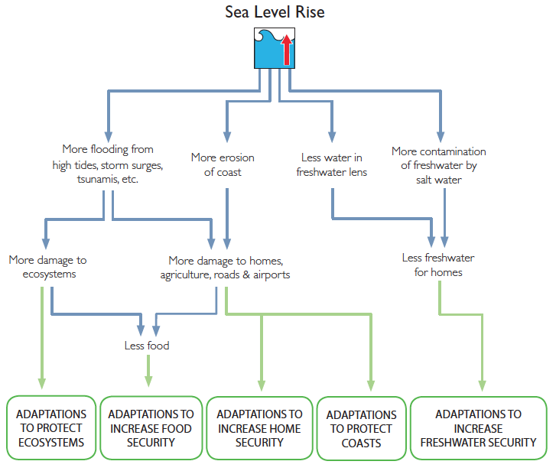

**Figure 14** *Impacts of sea level rise and kinds of adaptation strategies.*

**How can Federated States of Micronesia communities adapt to the impacts of climate change?**

We use the term **climate adaptation** to describe the things that people, communities and governments can do to help protect themselves from harmful climate impacts. A Pacific Island community that has planned and implemented climate adaptation strategies for their ecosystems, food supplies, homes, roads, and water supplies will suffer less damage and recover more quickly from climate change impacts.

Plants and animals living in Pacific Island ecosystems are adapted to the current conditions, such as temperatures and rainfall patterns. Since temperatures normally do not change very much over the course of a year, many local plants and animals have never experienced the higher temperatures that may be happening already and that are predicted to happen even more in the future. Changes in sea level and rainfall, higher temperatures, salt from ocean flooding, and a more acidic ocean all can cause very significant damage to land and marine ecosystems.

In addition to the stress from climate change impacts, these ecosystems are often already being harmed by other human actions. Activities such as polluting land or water, cutting down too many trees, catching too many fish, disturbing reefs, and replacing natural environments with industrial development all harm local ecosystems.

Ecosystems that are close to their natural condition are more **resilient** with respect to climate change. This means that they are damaged less by climate changes and can recover faster than ecosystems that are harmed by other human activities. The best climate adaptations for ecosystems are activities that help the ecosystems return to and keep their natural conditions. These activities include preventing and removing pollution, and carefully managing human interactions with the ecosystem such as fishing, cutting trees, and tourism.

Because ecosystems provide so many important benefits to island communities, these ecosystem adaptations also increase the resilience of human systems. In addition, human systems (such as homes, getting freshwater, getting food, and transportation) require other adaptation actions. These adaptation actions generally make the human systems more flexible, efficient and sustainable. In other words, these climate adaptations for human systems:

* Give the communities more ways to meet their needs (they are flexible),
* Do so in ways that provide the maximum benefits for the cost (they are efficient), and
* Rely more on island resources than on outside resources (they are sustainable).

Unfortunately, people living on low islands such as in FSM, have fewer choices and resources to reduce the impacts of climate change than do people who live on high islands or continents. Atolls lack the higher elevations that can provide much more security with respect to avoiding flooding, getting freshwater, growing food, and building roads. If the impacts of climate change continue to increase, atolls in the Federated States of Micronesia and their way of life will become increasingly threatened.

The Micronesia Conservation Trust has produced materials that help Pacific Island communities understand climate impacts. These materials provide guidance with respect to planning and implementing climate adaptation activities. Under the title *Adapting to a Changing Climate*, these materials include large flipcharts that can be brought to local communities and a booklet that summarizes and explains the information in the large charts[2].

In general, there are three kinds of climate adaptation activities that can help make people, communities, and nations safer with respect to rising sea levels and other climate impacts. These kinds of adaptation activities are:

* Protecting local ecosystems to help these ecosystems be more resilient,
* Increasing the resiliency of the communities’ physical systems such as homes, roads, water supplies, and food supplies,
* Making the community’s cultural systems stronger and healthier so people in the community effectively plan and implement climate adaptation strategies that work for that community.

These climate adaptations can help make life on the Federated States of Micronesia safer and more comfortable for more years into the future.

**Acknowledgements**

This essay has been produced by the Pacific Islands Climate Education Partnership (PCEP) as part of its work funded by the National Science Foundation (NSF) under Grant #1239733. The NSF funds research and education in most fields of science and engineering. Grantees are wholly responsible for conducting their project activities and preparing the results for publication. Thus, the Foundation does not assume responsibility for such findings or their interpretation.

Illustrations by Nancy Hulbirt, Anita Moorjani, and Jennifer Mendenhall.

**Photographs**

**Figure 5** Photograph of the Earth

http://earthobservatory.nasa.gov/Newsroom/NewImages/images.php3?img_id=4028

**Figure 12** Photograph of flooding on Kosrae

KIRMA – Kosrae Island Resource Management Authority

**Figure 13** Photograph of coral reef by Joe Ruhinski

http://fullhdwp.com/coral-reef-marshall-islands-majuro-atoll-wallpaper/

Feedback

What do you like or do not like about this booklet? We want any comments or advice that can help improve this booklet. Please share these with us by email to [fletcher@soest..hawaii.edu](mailto:fletcher@soest..hawaii.edu) and asussman@wested.org

We aim to produce similar booklets for other Pacific Island countries and states, especially those that are affiliated with the United States.

1. When something gets warmer, it expands (gets larger) in size. This increase in size happens with solids, liquids, and gases.
2. The booklet *Adapting to a Changing Climate* can be accessed at http://www.cakex.org/virtual-library/3439