Climate Change in American Samoa
Pacific Islands Climate Education Partnership 

You may have heard the term climate change. What does this term mean? In what ways is the climate changing? How does climate change affect American Samoa? The purpose of this booklet is to answer these questions.

What are weather and climate?
To learn about climate change we need to understand the difference between weather and climate. Weather is the short-term condition of the atmosphere in a specific place, such as where you live. Is it raining today? Where is the wind blowing from and how strong is it blowing? Is the air hot or cool? How cloudy is the sky?
Climate is the long-term average weather pattern in a specific place or larger area. When scientists describe the climate in a place, they use measurements and observations of the weather that have been made over periods of 30 years or longer. The climate in a place has very big effects on the plants, animals and people who live there.
The Territory of American Samoa has a climate where the weather changes over the course of a year from a wetter season to a drier season (Figure 1). Other places on our planet have climates where the weather changes a lot over the course of a year. For example, many places have very cold snowy winters, and very hot summers.
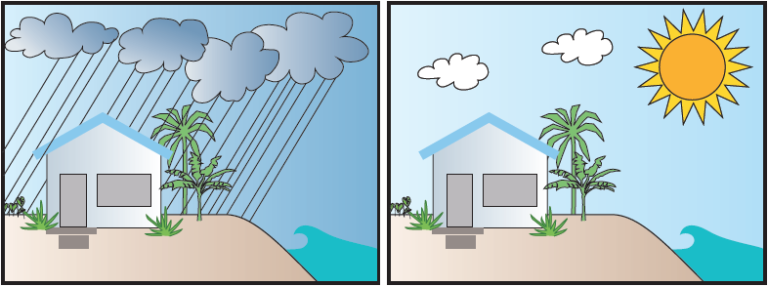

Figure 1 In American Samoa, the weather changes from a wetter and warmer season (October through May) to a drier and cooler season (June through September). On average 75% of Samoa’s total annual rainfall occurs in the wetter season.

Climate describes what kind of weather you can expect to happen. Weather describes what is actually happening. If you visit a place in the wet season, you should expect that it will be rainy. However, the days that you visit, the weather could actually be dry. It was probably rainy the week before you visited, and it will probably become rainy again after you leave.

What is the climate in American Samoa?

Warm and Humid

The climate in American Samoa is generally warm with windy conditions and with lots of water vapor in the air (this is known as high humidity). The map (Figure 2) shows two factors that play the biggest roles in causing this climate:

- American Samoa is located near the equator
- American Samoa is surrounded by the ocean in all directions

Places near the equator get a lot more energy from the Sun than places that are farther away from the equator. This location is the main reason that American Samoa is warm. The average annual

temperature is 80° F (27° C). Warm ocean water heats the air above it and also puts a lot of water vapor into that air. The warm ocean around American Samoa helps keep the temperature warm at night, and makes the air feel warm and humid.

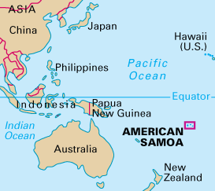

Figure 2 American Samoa is located in the south-central Pacific Ocean near the equator.

High Islands and Low Islands

There are two main kinds of islands in the Pacific Ocean: high islands and low islands.
Communities of people on both kinds of islands have homes, grow food, go fishing, and drink fresh water. The fresh water that they have comes from the rain that falls on their

island.

Figure 3 shows the two different kinds of rain that fall on Pacific islands. One kind of rain happens everywhere: over the open ocean, on low islands, and on high islands. This kind of rain happens because the air has so much water vapor in it that the water vapor condenses, forms clouds, and then precipitates. This is called convective rain.

High islands cause a second type of rain. When warm humid air is forced to rise up the slopes of a high island the cool air it encounters causes the water vapor to condense, making clouds and rain. This is called orographic rain.

American Samoa has both high islands (Tutuila, Ofu, and others) and low islands (Rose Atoll and Swains Island), and the high islands get more rain than the low islands. On the big, high island of Tutuila, the average annual rainfall ranges from about 120 inches (304 centimeters) along the coasts to as much as 300 inches (760 centimeters) in the high mountains. In the small islands and the flat atolls, about 100 inches (250 centimeters) of rain fall each year.

The fact that American Samoa’s high mountains get more rain than its coasts provides the clue why high islands get more rain than low islands. The air is much colder near the top of a high mountain compared with the bottom of that mountain. When warm, humid air blowing in from the ocean hits a mountain, that air is forced upward into the colder mountain areas. When warm humid air becomes colder, its water vapor condenses from the gas state into the liquid state, and forms water droplets. These water droplets become clouds that rain on the island.

Low islands are usually made of coral sand and gravel. Low islands do not cause humid air to condense because they do not extend into the cold air at high elevations. The main source of fresh water on a low island comes from rainstorms that move across the ocean and happen to run over the island.

Two Types of Rain on Pacific Islands
Everywhere (convective) Caused by Mountains (orographic)
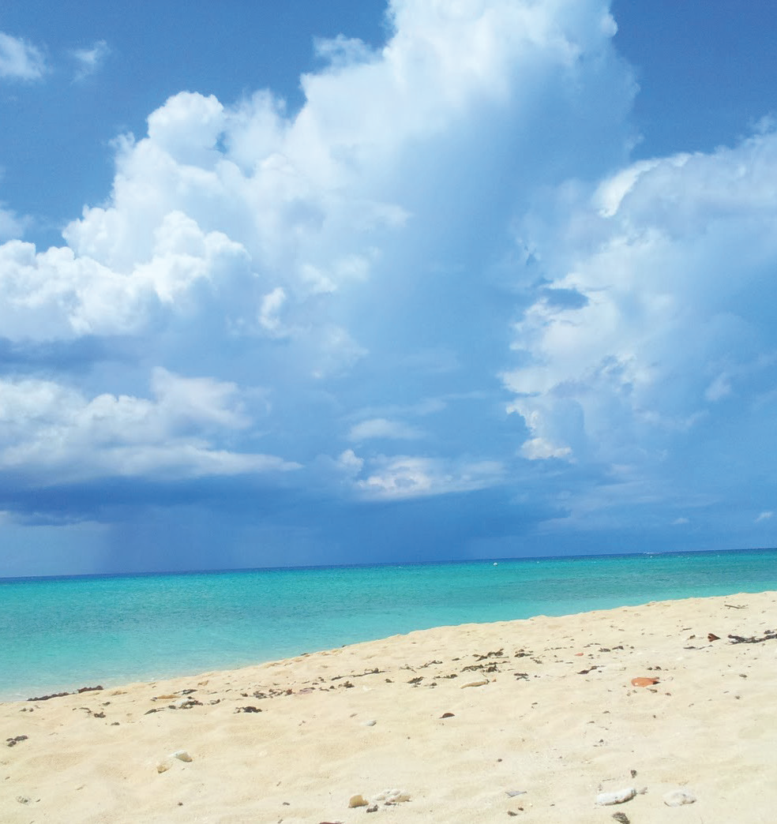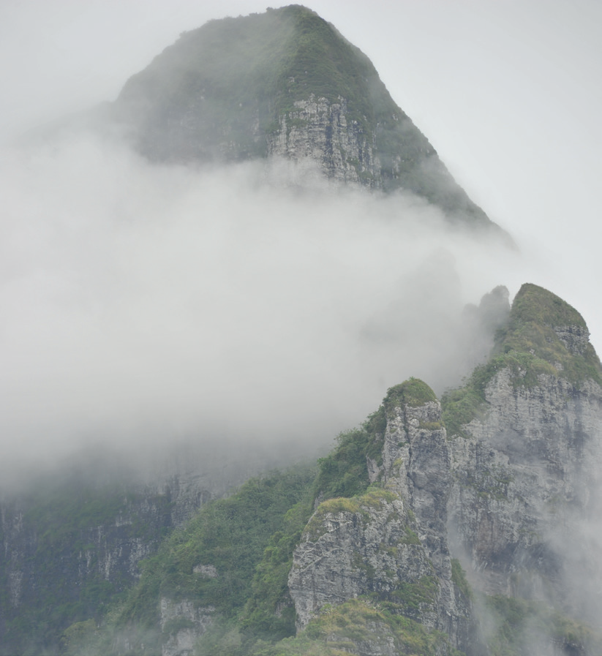

Air has so much water vapor that clouds
form, and rain falls on the open ocean and on any low or high islands that the clouds blow over.

Warm humid air becomes colder when
it rises up the slopes of a high island mountain. Cooled water vapor condenses and falls as rain on the high island.

Figure 3 The fresh water on Pacific islands comes from two types of rain.

Wetter and Drier Seasons with Variable Rainfall from Year to Year

The weather and climate in American Samoa (Figure 4) have been observed and analyzed for centuries, and have been scientifically measured for decades. There are several patterns in addition to being generally warm and humid. One of the most important climate patterns is that during the year there is a wetter season and a drier season.

The hot and humid rainy season extends from October through May. The drier season is usually between June and September when the average monthly rainfall is much less. Most Pacific Islands near the equator also have wet and dry seasons.

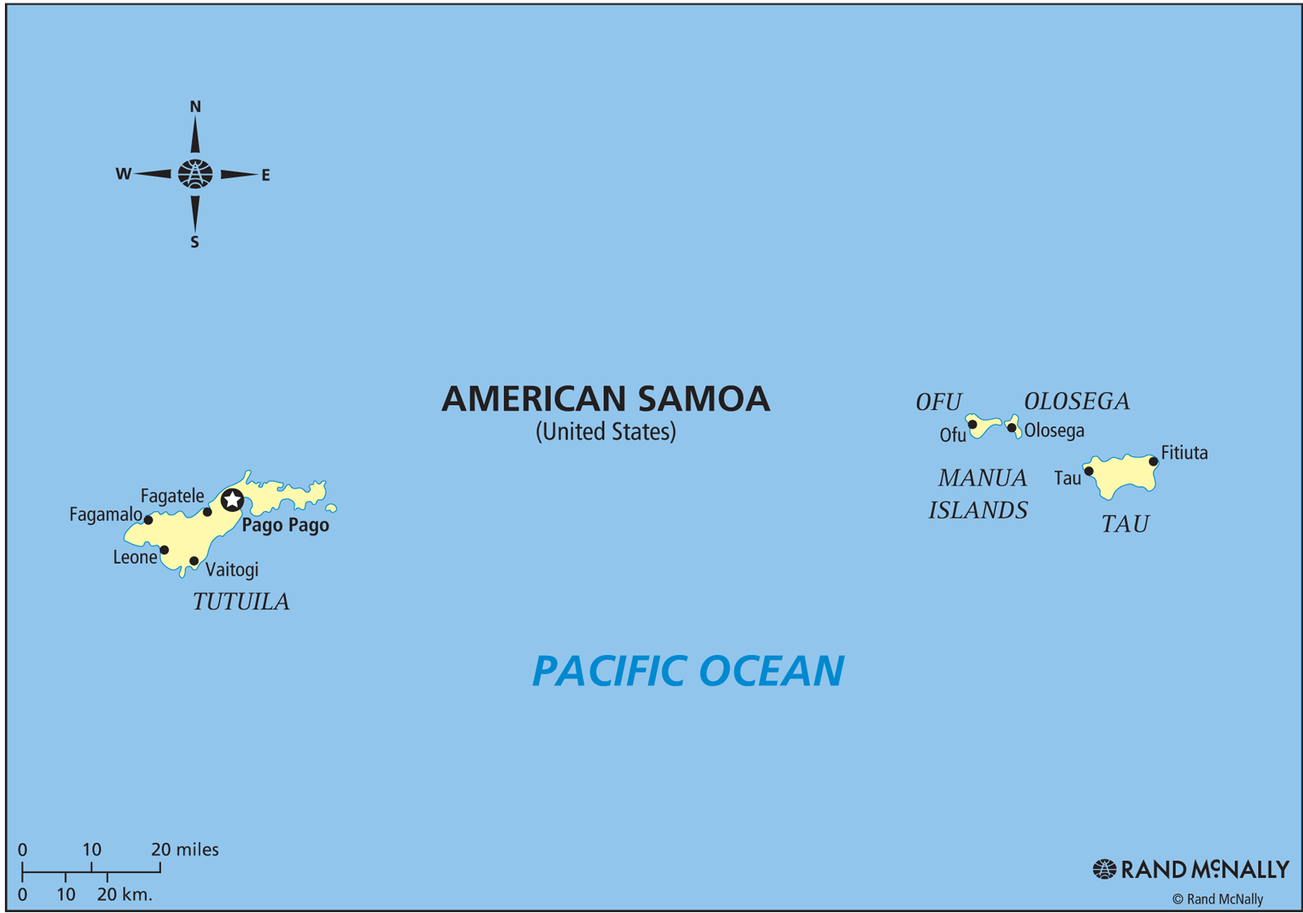

Figure 4 The Territory of American Samoa is located just south of 14°South latitude.

Figure 5 shows the annual rainfall measured in Apia, Western Samoa between the years 1890 and 2005. Note that the amount of rain changes a lot from year to year. Some years had 160 inches (400 centimeters) or more of rain, while other years had 80 inches (200 centimeters) or less of rain. This kind of change in rainfall from year to year is also a natural feature of the climate in many Pacific islands that are near the equator. Scientists say that the amount of rainfall has a lot of variability (natural change from year to year).

Figure 5 The amount of rainfall in Samoa has a lot of variability from one year to the next.

Regional Wind and Rain Patterns: The SPCZ and El Niño

Over American Samoa, the winds from the equator and from the southern hemisphere
come together and cause a band of rain called the South Pacific Convergence Zone or
SPCZ. This very cloudy and rainy area can be seen in satellite photos (Figure 6) as a band of thunderstorm clouds extending to the southeast from the equator.

The South Pacific Convergence Zone is a band of clouds extending southeast from the equator
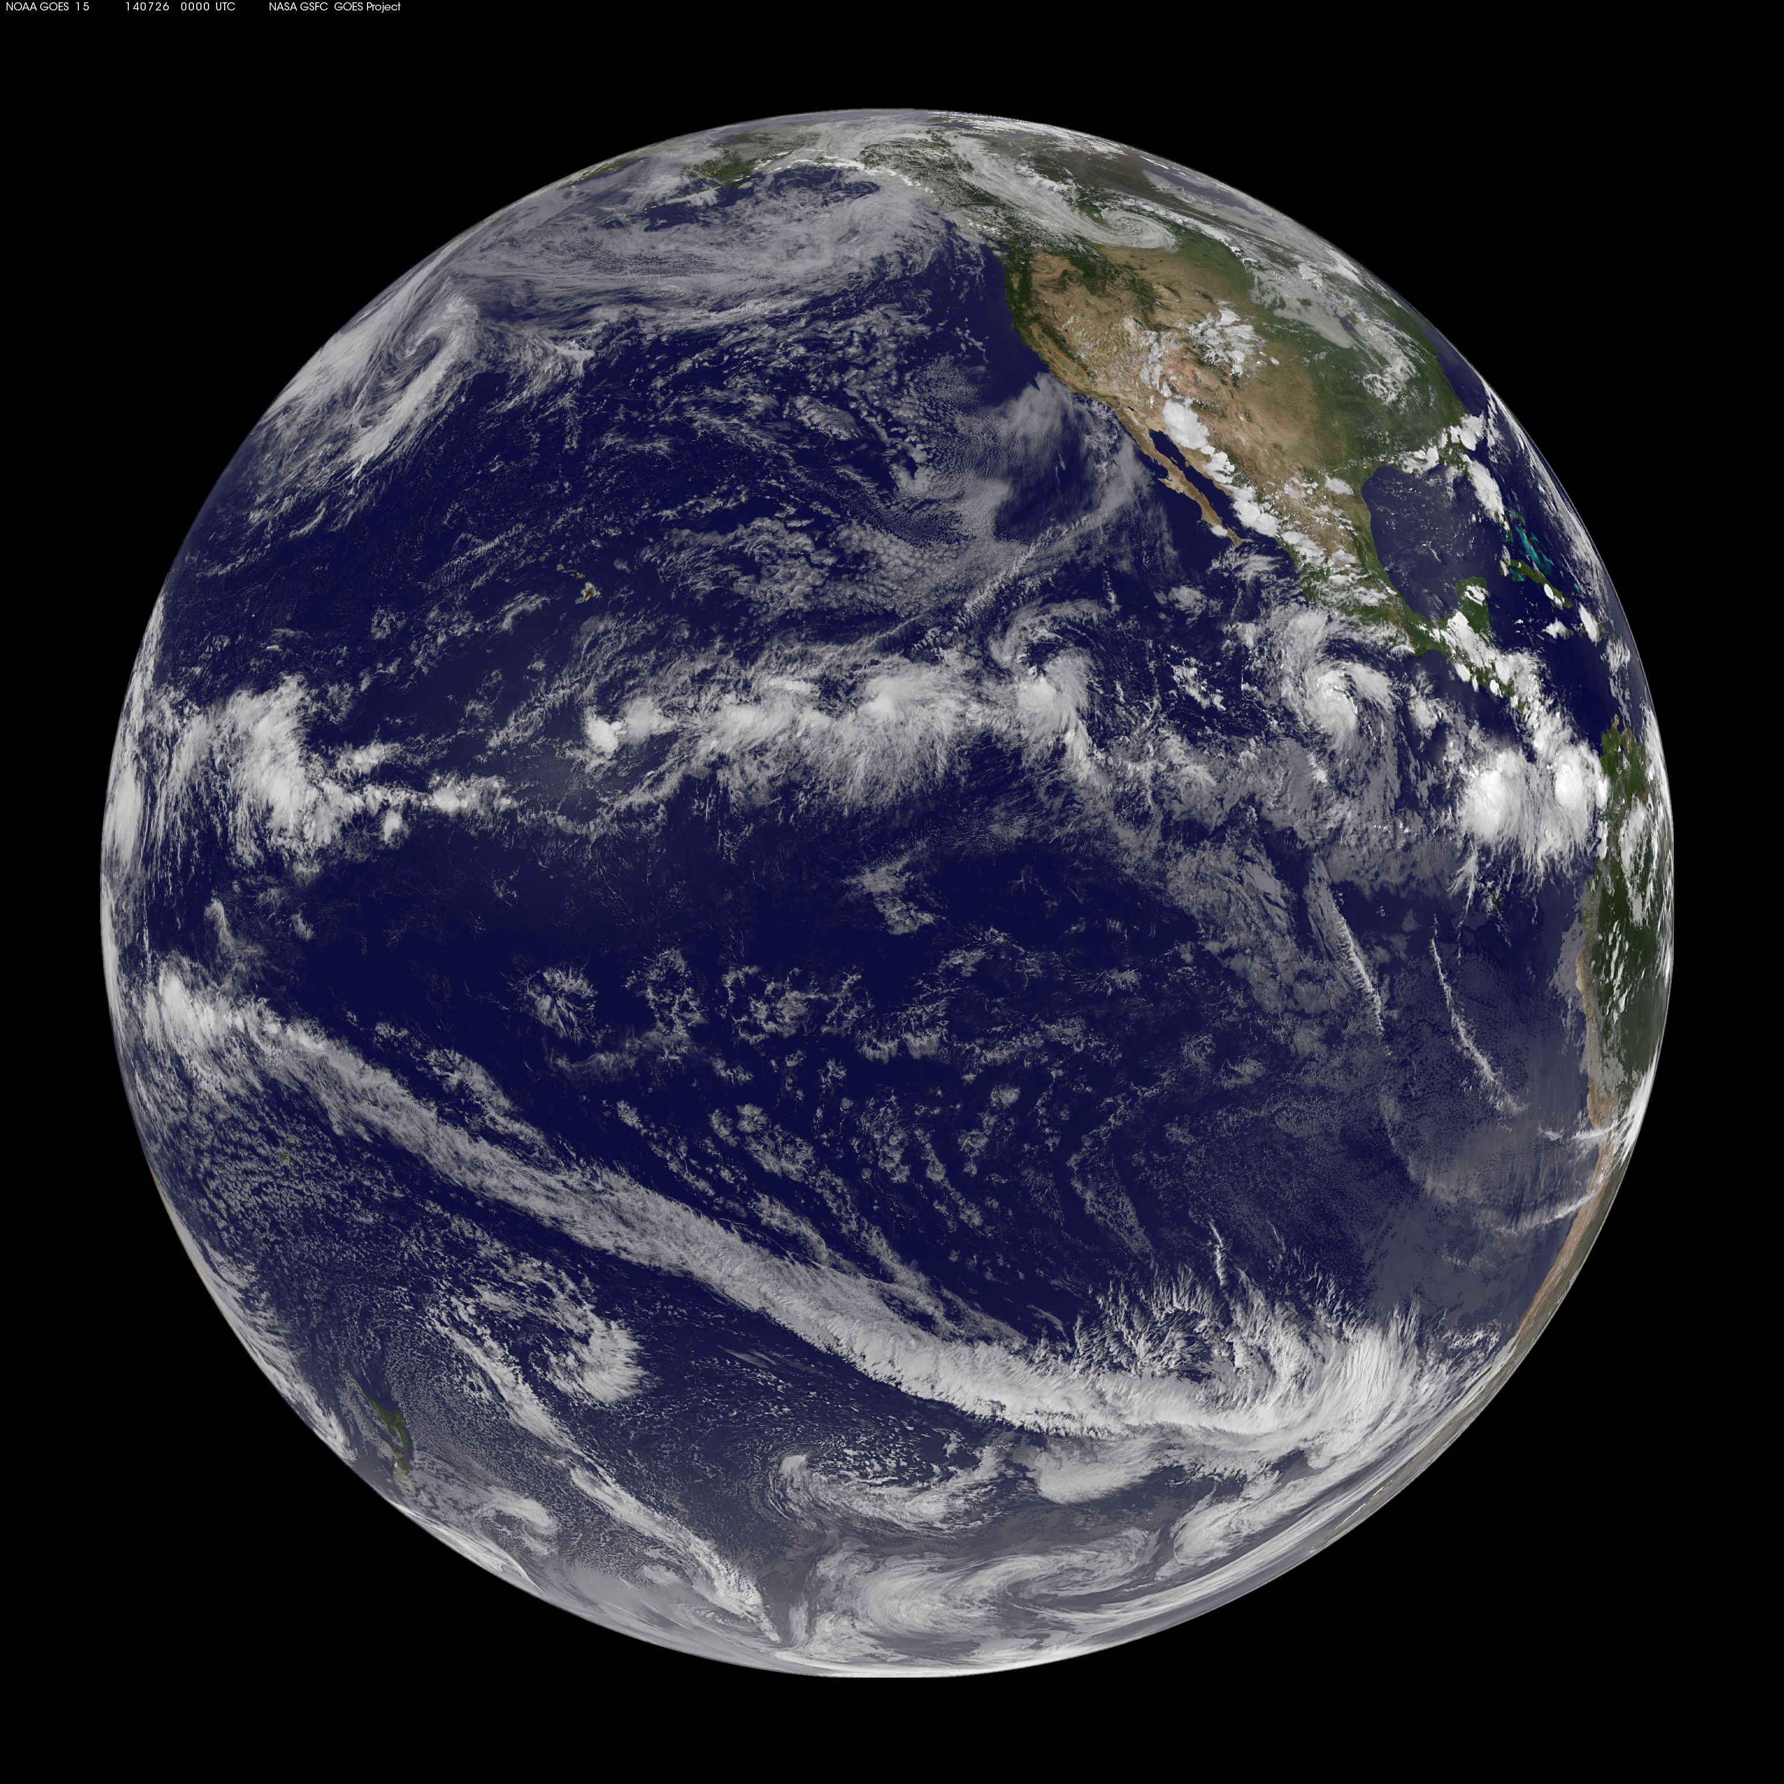 CROP

Figure 6 The strong sun and warm water of the tropics heats the air and increases its humidity. The warm humid air rises and becomes colder as it gets higher in the atmosphere. As the rising air gets colder, the water vapor condenses and forms big clouds that release the water in thunderstorms.

This long band of rainy area over the South Pacific Ocean does not just stay in one place. The wetter and warmer season occurs from October through May when the area of rain is located over American Samoa. The drier season occurs from June through September when the area of rain moves further north, toward the equator and away from American Samoa.

In American Samoa winds mostly blow from the southeast throughout the year. These winds are called trade winds. But there is a second type of wind, called a monsoon wind that sometimes blows from the west typically associated with bad weather. Trade wind conditions tend to dominate from June to September, and monsoon winds may occur during the wetter season from October through May.

The east to west trade winds play a large role in the climate of the equatorial Pacific Ocean. These winds can change during a climate pattern that is called the El Niño Southern Oscillation (ENSO). When trade winds are weaker than usual, scientists say that it is an El Niño year. When the trade winds are stronger than normal, scientists call it a La Niña year. When the winds are normal it is called a neutral year. Table 1 summarizes the differences between El Niño years, La Niña years, and neutral years.

Table 1 ENSO Conditions and the Effects of ENSO Changes

Feature | Neutral ENSO Year | El Niño ENSO Year | La Niña ENSO Year
Wind | Normal east to west trade winds | Weaker east to west trade winds; can even blow from west to east | Stronger east to west trade winds
Rainfall | Usual amounts of rainfall with normal variability | American Samoa tends to be drier than usual, and can experience drought | American Samoa tends to be wetter than usual and can experience damaging floods
Sea Level | Usual sea level with normal tide variability | Lower sea levels so high tides tend to cause less flooding | Higher sea levels so high tides tend to cause more flooding

Table 1 lists the differences between neutral years, El Niño years, and La Niña years.

In a neutral year (normal winds), the waters in American Samoa are much warmer than waters in the central or eastern portions of the Pacific Ocean. The warm water leads to strong evaporation and there is abundant rain.

In a La Niña year, strong winds blow across the ocean surface into the region of American Samoa. This raises the level of the ocean and can cause coastal erosion (land loss due to wave action) and damaging king tides (the highest tides of the year). La Niña years also tend to be rainy in American Samoa.

In an El Niño year, trade winds are weaker than normal (or absent). An El Niño year is usually drier and there is a greater chance of drought (an extended period of little rain). In addition, warm ocean water moves away from American Samoa toward the eastern Pacific Ocean, and causes sea levels to decrease.
Extreme Weather Events

Extreme weather events are another important climate feature. An extreme weather event is the kind of weather that can cause a lot of damage and problems for ecosystems and people. The main extreme weather events that happen in American Samoa are droughts and big storms.

Droughts typically occur in the months of June to September, especially in the year during or following an El Niño. During particularly strong El Niño drought, the rainfall can decrease by over 50%. This happened during the El Niño of 1998 when normal rainfall of 120 inches per year dropped to only 57 inches that year. However, scientists predict that in the future, droughts in American Samoa will either happen less often or stay approximately the same, and extreme rain events will happen more often. Scientists also predict little change in the overall amount of rainfall in American Samoa.

Very strong storms in the equatorial Pacific Ocean region are called tropical cyclones. These storms typically affect American Samoa from November and April and they have strong, damaging wind and very heavy rainfall. The number of cyclones varies widely from year to year but they tend to occur more frequently during moderate-intensity El Niño years and frequently during weak El Niño years.

Table 2 lists the main features of the climate in American Samoa.

Table 2 Main Climate Features

We can now list the main features of the climate in American Samoa
- Warm and humid days and nights all year
- Wetter and drier seasons
- Lots of variability in annual amounts of rain
- Breezy with trade winds normally blowing east to west
- Lots of variability in wind speed and wind direction
- Extreme weather events: drought and tropical cyclones
- Strong influence by climate conditions known as El Niño, La Niña and the position of the South Pacific Convergence Zone

Table 2 lists the main features of the climate in American Samoa.
What is happening to climate on our planet?

Our planet has been around for a very long time (more than four billion years). During that time the climate of the planet has changed many times. Sometimes the climate has been very cold, with large amounts of ice covering most of the land and even large parts of the ocean. Sometimes the climate has been very warm when even the polar regions had little or no ice.

For the past 10,000 years, Earth’s climate has been very comfortable for people and for ecosystems. However now, the climate is beginning to change because of human activities, especially our burning of fossil fuels (oil, coal and natural gas, which are made of fossil plankton and plants). Since our human activities are causing the global climate to become warmer, this change is often called global warming.

We use oil to make the fuel that provides the power for transportation (such as gasoline for cars, boats and trucks). People also burn fossil fuels to make electricity. When we burn oil and coal, the burning produces gases (especially carbon dioxide) that trap heat in the atmosphere. Other human activities are also producing gases that go into the atmosphere and trap heat (Figure 7). This trapping of heat in the atmosphere is causing Earth’s climate to get warmer.

Pollution from Burning Fossil Fuels
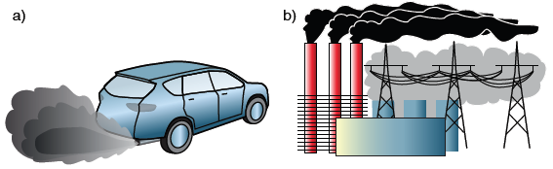

Figure 7 When we burn fossil fuels (oil, coal and natural gas), they produce gases that stay in
the atmosphere and trap heat, causing global warming. a) Oil is used to make gasoline to run
cars and trucks. b) Oil, coal and natural gas are burned to make electricity.

The graph of average global temperature over the past century shows that the global temperature has been increasing (Figure 8). The temperature data are collected from weather stations around the world. There is a lot of variability from year to year. However, over all the years in the graph, there is a clear trend that Earth’s climate has been getting warmer. Global temperatures in the last ten years are significantly higher than they have been for any other ten-year period.

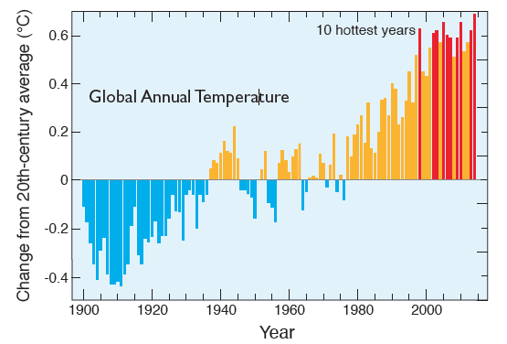

Figure 8 The annual average temperature of the air close to Earth’s surface.

Over the past 100 years, Earth’s temperature has increased about 1.6 °F (0.9 °C). While this amount may not seem very much to us, it is actually a lot for planet Earth. A decrease in global temperature of about 10 °F (5.6 °C) can cause an ice age. In the geologic past when Earth’s average temperature was 10 °F higher, most of Earth’s ice was gone and sea levels were 100 feet (30 meters) higher.

The higher global temperatures cause many other changes to weather patterns and conditions on the planet. As a result, scientists tend to use the broader term “climate change” to describe this issue, rather than global warming. These global climate changes include:

- Glaciers everywhere in the world are melting.
- Sea level is rising.
- The oceans are getting warmer.
- Ecosystems are moving away from current locations toward locations that are not as hot.
- Warm seasons are starting earlier and lasting longer.
- More of the planet is having tropical climate.
- Generally, wet places are getting wetter (flooding) and dry places are getting dryer (drought).

These and many other observations show that Earth’s climate system is rapidly changing because of global warming. Global climate change affects American Samoa in many ways. The rest of this booklet focuses on the changes that are already happening and the climate changes that are predicted to happen. We will also discuss what people in American Samoa can do to help protect themselves from the impacts (damaging effects) of climate change.

What impacts of climate change are happening in the
Marshall Islands?

As shown in Figure 9, the four most important impacts (damages) of global climate change in
American Samoa are:

- Higher air and ocean temperatures
- More extreme rain events
- Sea level rise
- Ocean acidification

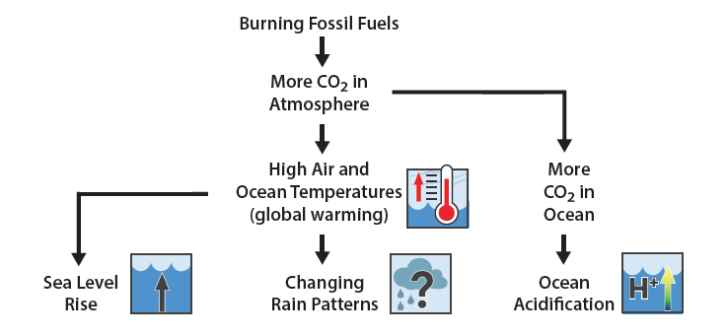
Figure 9 Human activities, mainly burning fossil fuels, are putting more heat-trapping gases, especially carbon dioxide, into the atmosphere. These activities are causing global warming. The four major impacts of climate change in the Marshall Islands are shown with a graphic image next to each one.

Global warming means that air and ocean temperatures are warmer. These higher temperatures can directly harm ecosystems and human communities. For instance, warmer ocean water is an unhealthy condition for coral reefs and fish. In addition, these higher temperatures are causing one of the most serious climate impacts: sea-level rise.

Higher ocean temperatures cause the oceans to have a larger volume. Thus, the ocean surface rises. This accounts for about 1/3 of the amount of global sea level rise. Higher air temperatures also cause mountain glaciers to melt, and this water flows into the ocean (accounting for another 1/3 of global sea level rise). The last 1/3 of global sea level rise comes from melting ice on Greenland and Antarctica. As a result of warming seawater and melting ice, oceans have a higher volume, and sea levels around the world are rising. Rising sea level causes coastal erosion and flooding by waves and high tides. During heavy rainstorms it can prevent the rain from draining into the sea, causing more flooding. This sea level rise is one of the most damaging impacts of climate change, especially for island communities.

Global warming also causes changes to rain patterns. For American Samoa, future average annual rainfall is predicted to stay about the same, but extreme rain events are predicted to increase. Periods of drought are predicted to decrease slightly, or stay about the same.

Ocean acidification is another major impact caused by higher carbon dioxide levels. When carbon dioxide dissolves in the ocean, it forms a weak acid. As excess carbon dioxide in the atmosphere dissolves in the ocean, it changes the acid-base chemistry of the ocean, and causes seawater to become more acidic. Ocean acidification is included as a climate change impact because it is caused by the same increase in carbon dioxide that causes the other climate change impacts. Ocean acidification also harms many of the same marine ecosystems, especially coral reefs, plankton, and shellfish that are additionally harmed by higher ocean temperatures.

How do these climate change impacts harm ecosystems and human systems in American Samoa?

Many people think that humans should protect the natural world. All four of the climate change impacts shown in Figure 9 (sea level rise, higher temperatures, drought, and ocean acidification) harm American Samoa ecosystems. These impacts harm the organisms that live there and the human communities that get many benefits from these ecosystems. These benefits include cultural and spiritual values, food, and income from fishing and tourism (Figure 10).
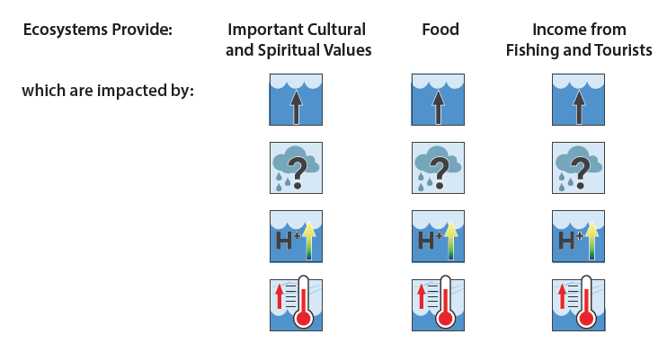
Figure 10 Sea level rise, drought, ocean acidification and higher temperatures all damage major services that are provided by ecosystems.

In addition, climate changes harm the human systems that people depend upon for their homes, food, fresh water, and transportation (Figure 11).
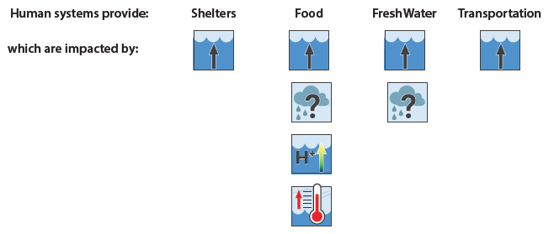
Figure 11 Climate change damages major services that are provided by human systems.

Sea level rise is especially important since it harms essentially all American Samoa ecosystems and human systems. Sea level has been increasing in American Samoa at about 0.1 inches per year. This may not seem like a very rapid increase, but its effects can quickly add up year after year. Sea level rise causes beach erosion (Figure 12), flooding during high tide, and increased flooding due to storm surge and tsunamis. Sea level is expected to continue rising, perhaps by more than 3 feet (1 meter) by the year 2100.

This increase in sea level means that anything that makes the ocean waves reach farther inland (such as a high tide, a tsunami, or a large storm) will cause more flooding than when the sea level was lower. For example, a deadly tsunami struck American Samoa in 2009, and because of long-term sea level rise over the past century, it caused more damage than it would have if sea level had not been rising.

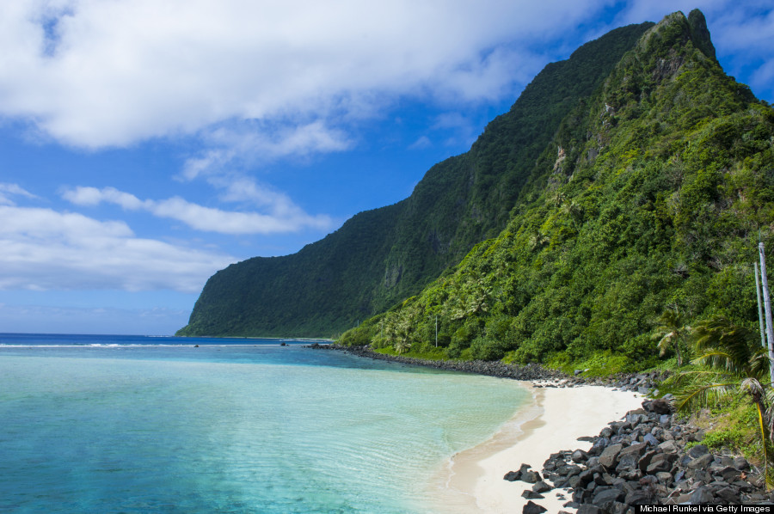 CROP left side

Figure 12 Sea level rise causes beach erosion, which can make beaches get narrower and eventually disappear.

Higher sea level also affects the availability of food and water. When the ocean floods the land, the soil becomes salty, which damages the natural plants and trees, and also makes it much harder to grow food. The higher sea level can also reduce the amount and quality of the underground fresh water.

Often the different impacts of climate change harm the same ecosystem or human system, and cause more damage than either would by itself. For example, higher ocean temperatures and ocean acidification both harm local marine ecosystems such as coral reefs (Figure 13). Coral are very sensitive to increases in temperature. Since the 1970’s the water has warmed about 1.4°F (0.8°C) across the entire nation of RMI. Warmer ocean water can lead to coral bleaching, and damage to local marine ecosystems and fishing.

The outside hard parts of many shelled organisms, such as plankton, and coral are made of carbon combined with calcium and oxygen in a solid form called calcium carbonate. As the ocean becomes more acidic, it is much more difficult for many marine organisms to make and keep their hard calcium carbonate shells. Since plankton and coral are very important for marine ecosystems, this ocean acidification also can decrease the populations of many marine organisms that do not have shells. One quarter of all sea animals spend time in coral reef environments during their life cycle.

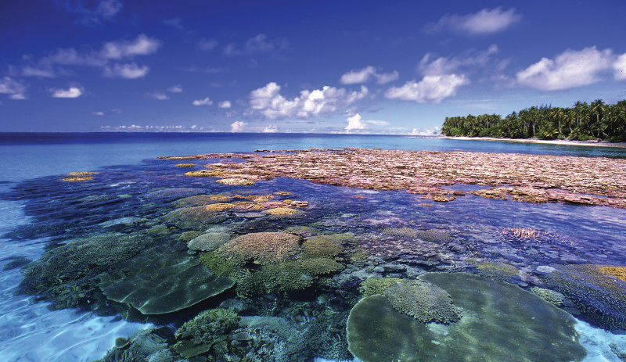

Figure 13 Ocean acidification harms the coral, plankton, and other organisms that use calcium carbonate to make their shells and the reef. Coral reefs are also damaged by higher ocean temperatures.

How can American Samoa communities adapt to the impacts
of climate change?

Plants and animals living in Pacific Island ecosystems are adapted to the current conditions, such as temperatures and rainfall patterns. Since temperatures normally do not change very much over the course of a year, many local plants and animals have never experienced the higher temperatures that may be happening already and that are predicted to happen even more in the future. Changes in sea level (Figure 14) and rainfall, higher temperatures, salt from ocean flooding, and a more acidic ocean all can cause very significant damage to land and marine ecosystems.

In addition to the stress from climate change impacts, these ecosystems are often already being harmed by other human actions. Activities such as polluting land or water, cutting down too many trees, catching too many fish, disturbing reefs, and replacing natural environments with industrial development all harm local ecosystems.
Ecosystems that are close to their natural condition are more resilient with respect to climate change. This means that they are damaged less by climate changes and can recover faster than ecosystems that are harmed by other human activities. The best climate adaptations for ecosystems are activities that help the ecosystems return to and keep their natural conditions. These activities include preventing and removing pollution, and carefully managing human interactions with the ecosystem such as fishing, cutting trees, and tourism.

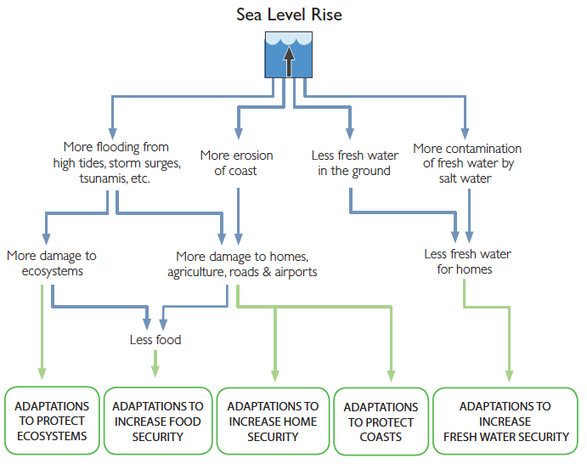
Figure 14 Impacts of sea level rise and kinds of adaptation strategies.

Because ecosystems provide so many important benefits to island communities, these ecosystem adaptations also increase the resilience of human systems. In addition, human systems (such as homes, getting freshwater, getting food, and transportation) require other adaptation actions. These adaptation actions generally make the human systems more flexible, efficient and sustainable. In other words, these climate adaptations for human systems:
- Give the communities more ways to meet their needs (they are flexible),
- Do so in ways that provide the maximum benefits for the cost (they are efficient), and
- Rely more on island resources than on outside resources (they are sustainable).

Unfortunately, on low islands, have fewer choices and resources to reduce the impacts of climate change than do communities on high islands or continents. Low atolls lack the higher elevations that can provide much more security with respect to avoiding flooding, getting fresh water, growing food, and building roads. If the impacts of climate change continue to increase, the low islands in American Samoa, and their way of life, will become increasingly threatened.

The Micronesia Conservation Trust has produced materials that help Pacific Island communities understand climate impacts. These materials provide guidance with respect to planning and implementing climate adaptation activities. Under the title Adapting to a Changing Climate, these materials include large flipcharts that can be brought to local communities and a booklet that summarizes and explains the information in the large charts.

In general, there are three kinds of climate adaptation activities that can help make people, communities, and nations safer with respect to rising sea levels and other climate impacts. These kinds of adaptation activities are:
- Protecting local ecosystems to help these ecosystems be more resilient,
- Increasing the resiliency of the communities’ physical systems such as homes, roads, water supplies, and food supplies,
- Making the community’s cultural systems stronger and healthier so people in the community effectively plan and implement climate adaptation strategies that work for that community.

These climate adaptations can help make life in American Samoa safer and more comfortable for more years into the future.

Insert Glossary from RMI and end notes.

FIGURE 12 is from Peter Craig, National Park Service - NPS Sea and Landscapes Photo Gallery
https://en.wikipedia.org/wiki/National_Park_of_American_Samoa#/media/File:Ofu_Beach_NPS.jpg

Pacific Climate Change Science Program, Australian Govt., 2014. Climate Variability, Extremes and Change in the Western Tropical Pacific: New Science and Updated Country Reports, Chapter 12 - Samoa, www.pacificclimatechangescience.org
NOAA Tech. Rept. NESDIS 142-8, 2013, Regional Climate Trends and Scenarios for the U.S. National Climate Assessment: https://www.google.com/search?q=noaa_nesdis_tech_report_142-8-climate&ie=utf-8&oe=utf-8
When something gets warmer, it expands (gets larger) in size. This increase in size happens with solids, liquids, and gases.
The booklet Adapting to a Changing Climate can be accessed at http://www.cakex.org/virtual-library/3439

