HOT 263 & 264: Questionable Pressure Data
Jasmine S. Nahorniak
September 4, 2015
The pressure values for the HOT 263 and 264 casts are questionable. This was due to a malfunctioning pressure sensor. This sensor malfunctioned from June 1 2014 until its repair on July 24 2014. The two cruises HOT 263 and 264 took place during this time interval.

Pressure Tare Values
One symptom of a bad pressure sensor is bad pressure tare values. A typical good on deck pressure tare is approximately 9.83 +/- 0.1 dB. The on deck pressure tares for HOT 263 and 264 are listed in Table 1. For HOT 263, two out of the three pressure tare values were bad. For HOT 264, all pressure tares were bad. Note that although the values seem reasonable (approx. 9.83 dB) for Station Kahe during HOT 263 this does not guarantee that the pressure data from the associated casts are accurate.

Table 1: On deck pressure tare values and velocity profile assessments for each of the casts collected on the HOT 263 and 264 cruises. The text colors indicate the data quality: bad (red), poor (blue), and good (black).
Cruise_Station_Cast | On Deck  Pressure Tare (dB) | Velocity Profile  Assessment
h263_aloha1 | 4.93 | awful
h263_aloha2 | 4.93 | awful
h263_aloha3 | 1.66 | poor
h263_aloha4 | 1.66 | poor
h263_aloha5 | 1.66 | poor
h263_kahe_1 | 9.83 | awful
h263_kahe_2 | 9.83 | awful
h264_aloha1 | 6.16 | poor
h264_aloha2 | 6.16 | poor
h264_aloha3 | 4.44 | poor
h264_aloha4 | 4.44 | poor
h264_kahe1 | 4.30 | poor
h264_kahe2 | 4.30 | poor

Cast velocity
Another symptom that indicates a bad pressure sensor is an erratic cast velocity. In normal circumstances, the vertical cast velocity shows only minor variability over the duration of the cast (see Figure 1 below for an example). When the pressure sensor is behaving erratically, it causes unrealistic variations in the vertical velocity (Figure 2). Note that if the pressure sensor error was simply an offset error (e.g. all pressure values were off by 2 dB), the velocity profile would look normal. All of the “awful” velocity profiles from HOT 263 and 264 looked similar to Figure 2, indicating that the pressure sensor error is erratic and not simply an offset.
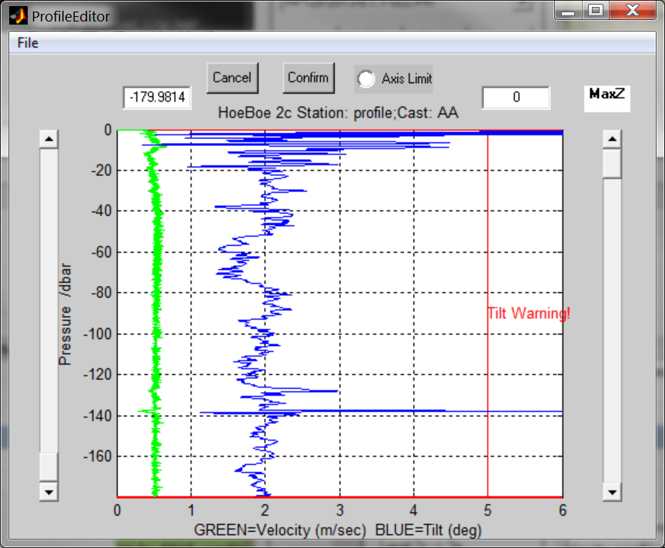Figure 1: A sample reasonable velocity profile (green line) (hb2c_0618_profile2). | 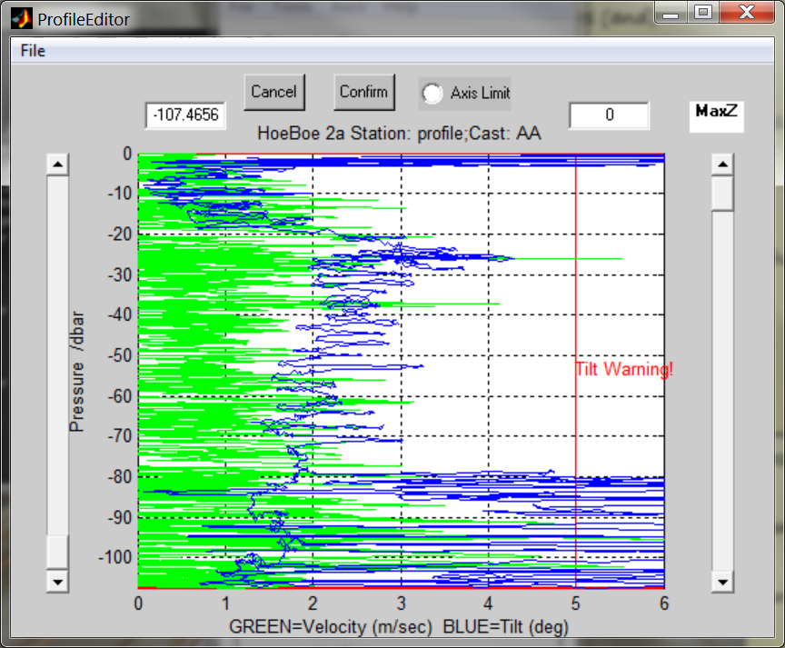  Figure 2: A sample poor velocity profile (green line) (hb2a_0605_profile1).

For HOT 263 and 264, the velocity status for each cast is listed in Table 1. Only three of the sixteen casts are likely to contain accurate pressure data. For these two cruises, the pressure data from all of the profiles are either “awful” or “poor” and should not be used.

Data processing
The output can be found in the “subset” and “figures” folders. Note that visually the profiles for temperature, etc. look fine. However, please be warned that although it isn’t obvious, the pressure data are inaccurate. Data points within each profile are slightly out of order.

Summary
The pressure data from all casts collected during HOT 263 and 264 are highly questionable. Pressure data and profile figures from these casts should be treated with a high degree of caution. The profile figures may be used to provide information about the range of values at that location for the various parameters (e.g. salinity range 35.1 – 35.6), but any evaluation involving depth (e.g. depth of the chl max, comparison with CTD profiles, or inference of the water column structure from the profile shape) is not advised.

