Papohaku Beach, Molokai - Erosion Analysis

Coastal Geology Group
University of Hawaii Manoa
February 2005

This report and noted erosion poster are available @:
ftp://soest.hawaii.edu/coastal/webftp/Molokai/papohaku/

Project Overview: This project generated beach erosion values (ft/yr) at 20-meter intervals along Papohaku Beach, Molokai. Erosion values were generated via linear regression by comparing High Water Mark (HWM) shoreline positions over time. HWM shorelines were derived from the following T-sheet and aerial photo sources:

- 1915 T-sheet
- 1925 T-sheet (northern portion of beach)
- 1950 aerial
- 1958 aerial
- 1968 aerial
- 1977 aerial
- 2000 aerial

The 1915 and 1925 HWM shorelines are drawn on T-sheets and were subsequently digitized for this study. Aerial HWM shorelines were identified by beach debris lines and/or erosion scarp shadows visible on photographs. Contrast settings were manipulated to enhance these beach features so as to improve HWM identification prior to digitization.

Shoreline Uncertainty: Each HWM shoreline used in the study contains uncertainty. Uncertainty values were not used during erosion value generation. Major sources of uncertainty may come from:

- Differences in x,y pixel positions between source images – how accurately images overlay each other.
- The 1915 and 1925 T-sheet surveyors ability to accurately note a high water mark.
- The digitizer’s ability to accurately vectorize the high water mark from aerial sources.
- In addition, seasonal shifts in the beach widths may add error when generating erosion values from different high water mark positions over time.

Projected Hazard Line: A 100 year erosion hazard line was produced by projecting the 2000 vegetation line inland by the associated beach erosion rate (ft/yr erosion rate x 100 years). Points were generated every 100 meters along the hazard line for possible field use.

Project Results: Analysis results are displayed in the following poster.

Poster includes:
- 2000 aerial photo base image
- Historic HWM shoreline vectors
- Baseline and Transects
- Erosion values (ft/yr) associated with each transect
- 2000 Vegetation Line
- 100 Year Erosion Hazard Line with spot coordinate pairs to guide possible field work
- Additional relevant map elements

Data Sources: The following pages contain the images (both T-sheet and aerial) from which the HWM shorelines were derived for use in this erosion analysis. Comments concerning rectification and general observations of each image are given.

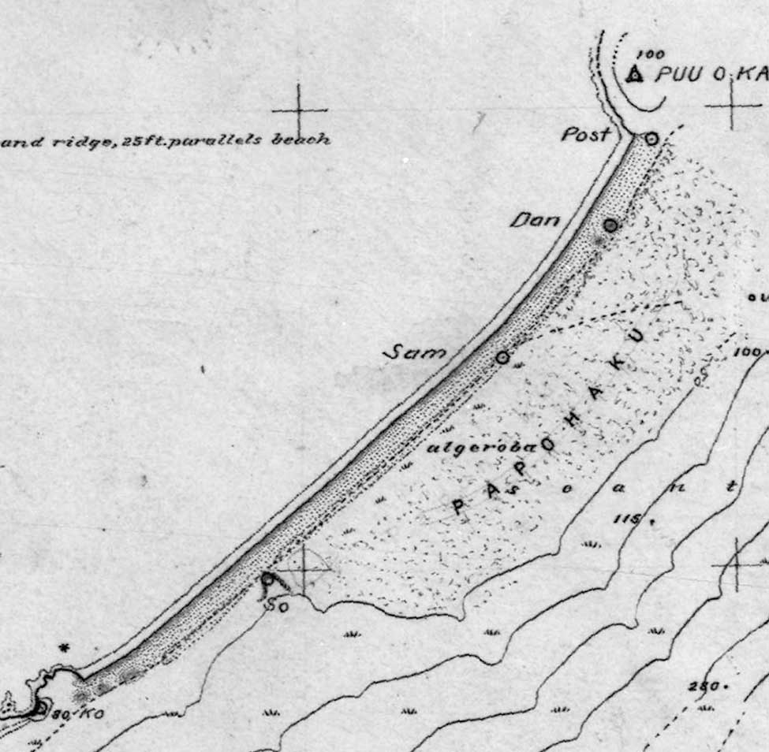
- Topographic Survey (T-Sheet): Survey Date: 1915

- Rectification Notes: Image rectified to the UTM Zone 4 North - NAD83 system (via 1st order polynomial w/ an RMS of 2.5m) utilizing visible graticules. Rectified image deemed suitable for use after t-sheet headland and control point locations were compared with modern day equivalents. Slight post-rectification adjustments were made to best match t-sheet control points to modern day control point array.

- Image Notes: Earliest Shoreline used in this study. Beach appears to have been surveyed during fuller width period (summer months) though no month is actually listed on T-sheet. Reference “sand Ridge, 25ft. parallels beach’ appears on T-sheet – evidence of historic beach dune system. Vegetation listed as “algeroba”. Heavy black shoreline used for erosion analysis.

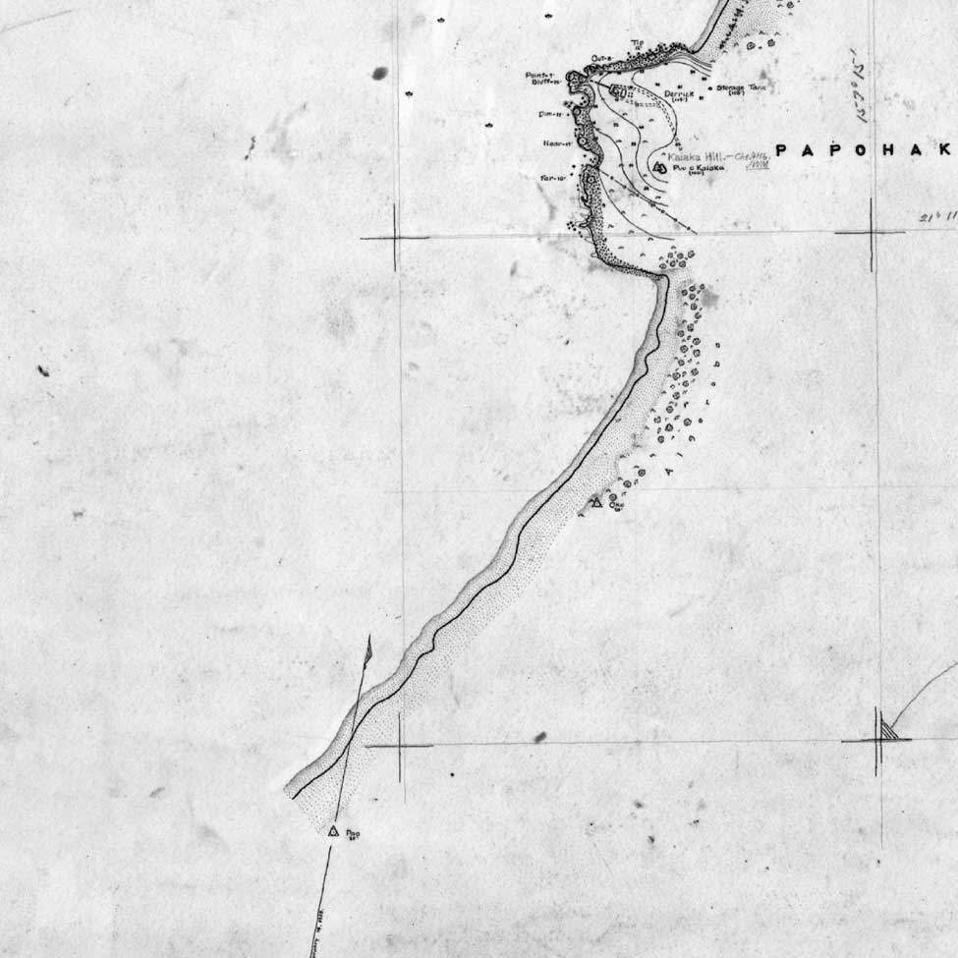
- Topographic Survey (T-Sheet): Survey Date: February, 1925

- Rectification Notes: Image rectified to the UTM Zone 4 North - NAD83 system (via 1st order polynomial w/ an RMS of 1.2m) utilizing visible graticules. Rectified image deemed suitable for use after t-sheet headland and control point locations were compared with modern day equivalents. Slight post-rectification adjustments were made to best match t-sheet control points to modern day control point array.

- Image Notes: More detailed survey than previous 1915 t-sheet but only covers northern portion of beach. Survey month (February) and cusped HWM line indicate possible winter seasonal erosion at time of survey. Vegetation listed as “algeroba”. Heavy black shoreline used for erosion analysis.

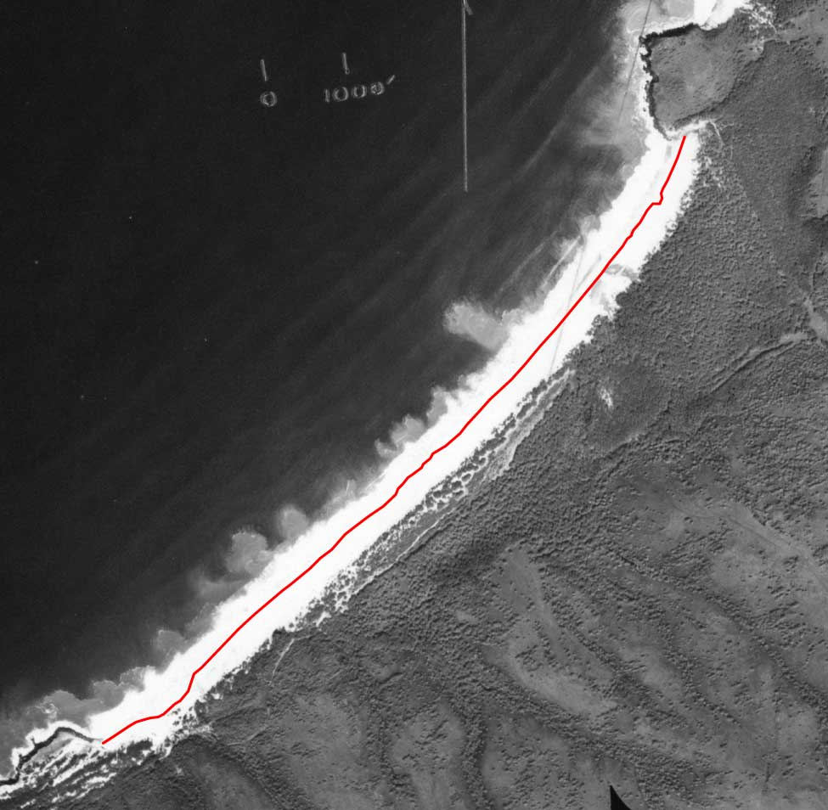
- Aerial Photograph - Photo Date: February 1st, 1950

- Rectification Notes: Image rectified to the UTM Zone 4 North - NAD83 system (via 2nd order polynomial w/ an RMS of 3.1m) utilizing visual control points pulled from 2000 DOQQ.

- Image Notes: Though beach was photographed in February (winter) it appears to have a fuller width associated with summer months, especially at north end. The vector shoreline (above) used for erosion analysis was drawn from visual high water mark clues from both raw and enhanced versions of the scanned aerial photograph.

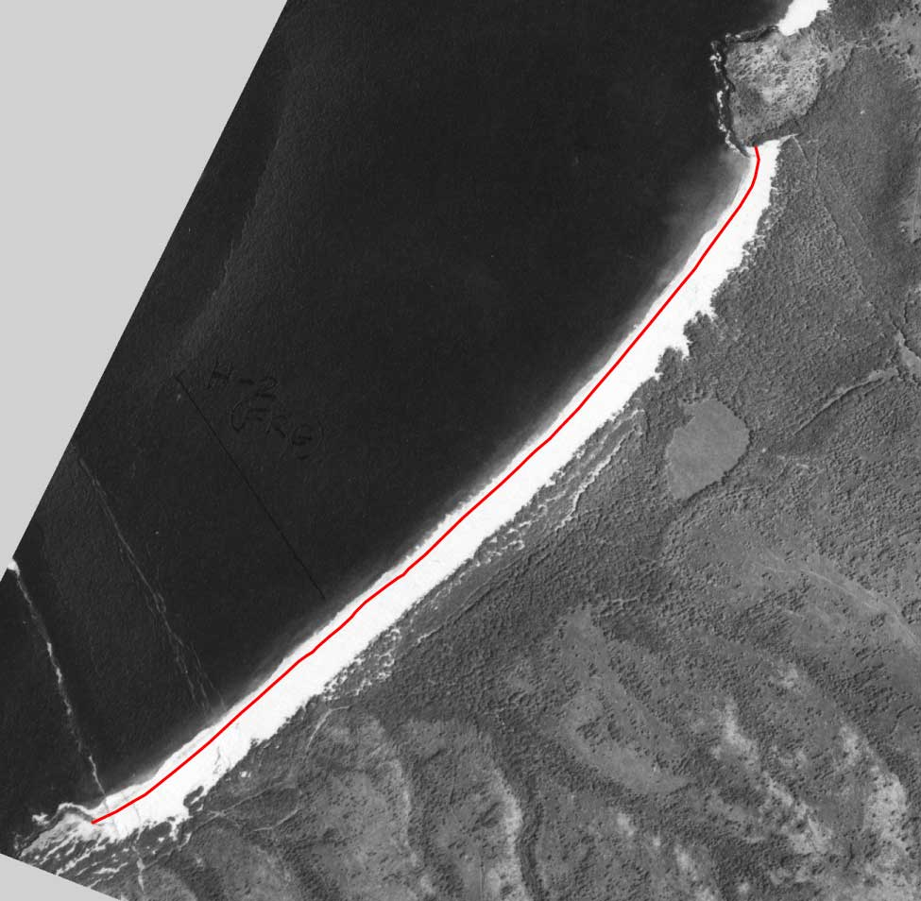
- Aerial Photograph - Photo Date: April 28th, 1958

- Rectification Notes: Image rectified to the UTM Zone 4 North - NAD83 system (via 2nd order polynomial w/ an RMS of 3.1m) utilizing visual control points pulled from a 2000 DOQQ.
- Image Notes: Fuller beach width – small waves when photo taken. Similar beach structure to 1915 T-sheet. The vector shoreline (above) used for erosion analysis was drawn from visual high water mark clues from both raw and enhanced versions of the scanned aerial photograph.

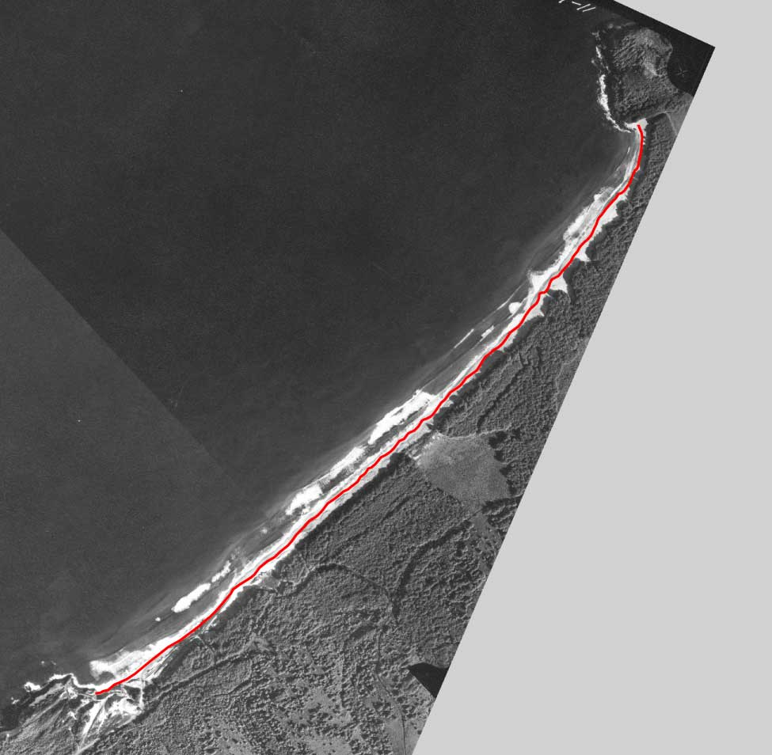
- Aerial Photograph - Photo Date: January 7th, 1968

- Rectification Notes: Image rectified to the UTM Zone 4 North - NAD83 system (via orthorectification w/ an RMS of 4m) utilizing visual control points pulled from a 2000 DOQQ.

- Image Notes: Heavy winter seasonal erosion with clear cusping/scarping at time of photo. Active sand mining operations visible at south end of beach. Note: Heavy vegetation shadow line located on beach. The vector shoreline (above) used for erosion analysis was drawn from visual high water mark clues from both raw and enhanced versions of the scanned aerial photograph.

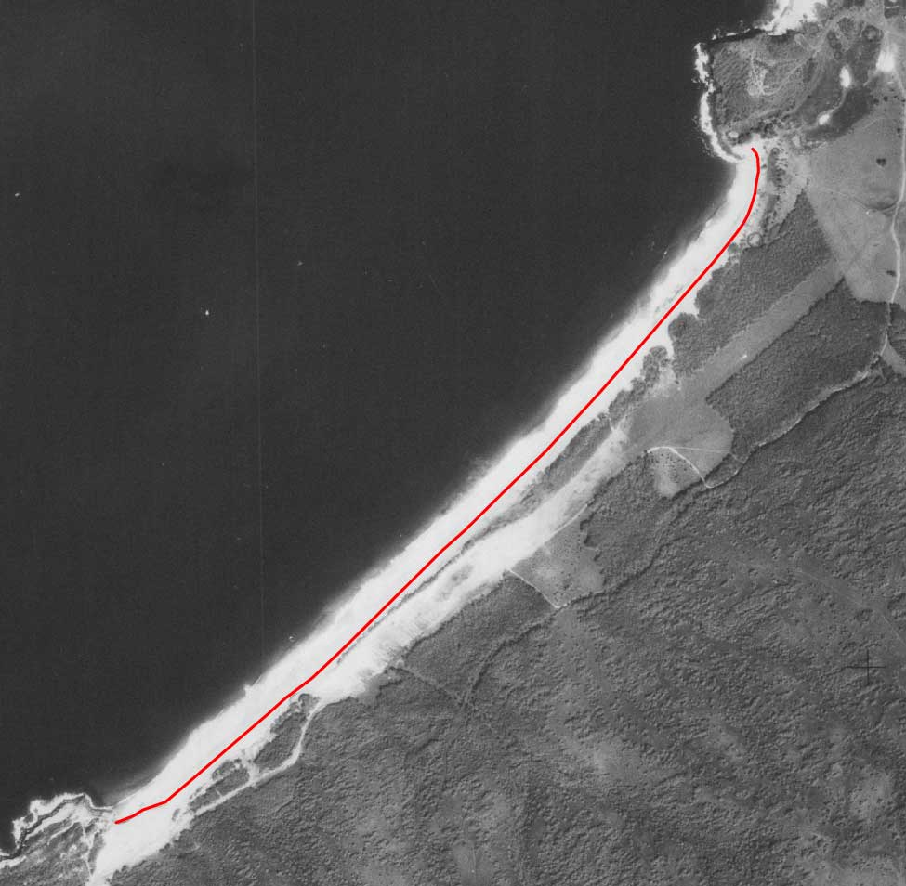
- Aerial Photograph - Photo Date: January and March 1977

- Rectification Notes: Image rectified to the UTM Zone 4 North - NAD83 system (via 1st order polynomial w/ an RMS of 1.3m) utilizing visible graticules. The image is from a scan of an original paper USGS orthophoto product.

- Image Notes: Airstrip apparent. The vector shoreline (above) used for erosion analysis was drawn from visual high water mark clues from both raw and enhanced versions of the scanned aerial photograph.

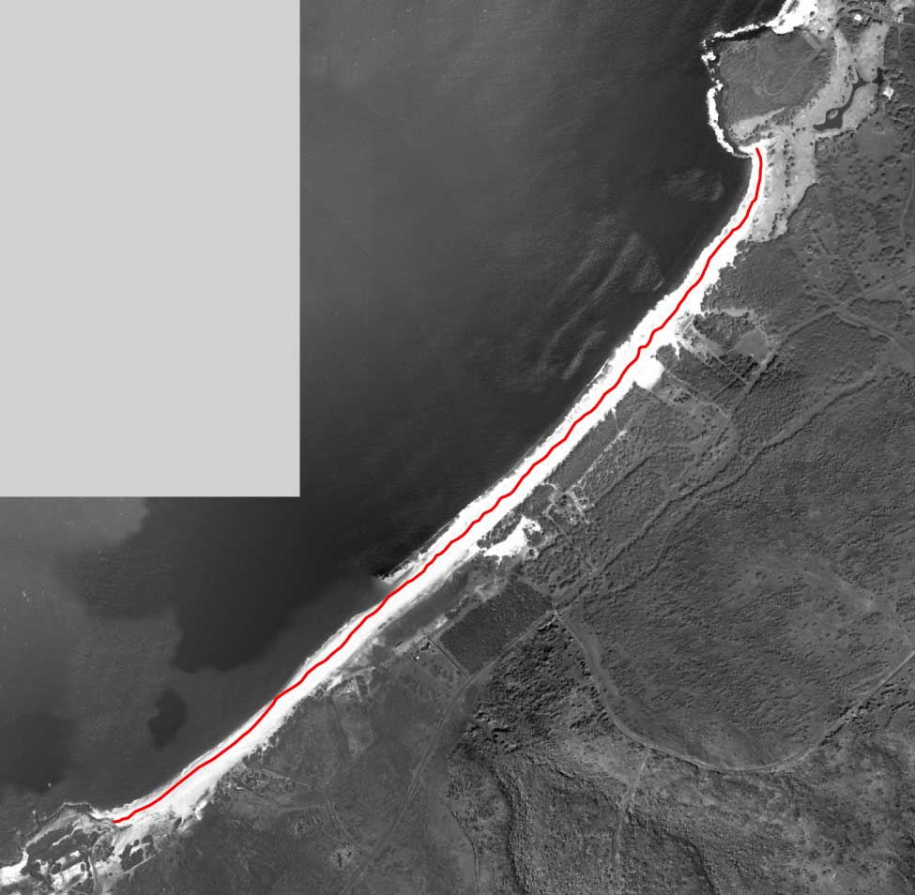
- Aerial Photograph - Aerial Photo Date: 2000

- Rectification Notes: 2000 DOQQ – this pre-rectified aerial source was taken as is and used for both 2000 HWM generation but also a control source used to rectify older aerials in this study.

- Image Notes: The vector shoreline (above) used for erosion analysis was drawn from visual high water mark clues from both raw and enhanced versions of the scanned aerial photograph.

Annual Erosion Hazard Rate plots (m/yr) for Papohaku Beach transects (156 @ 20m)

