Adoption of Erosion Rate-Based Setbacks in Maui, Hawaii: Observations and Lessons Learned

Z. M. Norcross-Nu’u¹ and T. Abbott²

Abstract

Inadequate construction setbacks over the last century on the Hawaiian island of Maui have led to a heavy reliance on shoreline armoring for structures now facing erosion crises. Along 56 miles of sandy shoreline, over 370 shore protection structures, such as seawalls, revetments and groins, have been built, nearly two thirds of which have been identified in an unpublished study as likely having a negative impact on the adjacent sandy beach. In November 2003, Maui County set a precedent for shoreline protection among the counties of Hawaii by being the first to adopt erosion rate-based construction setback rules. The process of producing erosion rate data and creating and adopting the new setback rules took over 5 years. A significant amount of input was received from the public through an advisory committee, public workshops and public hearings. Following the adoption of the new rules, planning and permitting situations have arisen that have revealed limitations in the rules. These issues are currently being addressed on a case-by-case basis, but it is likely that further amendments will be necessary.

Introduction
In the state of Hawaii, minimum development setbacks are established in the state’s coastal zone management statute. This statute gives the ultimate authority in creation and enforcement of setback rules to the individual counties of Hawaii, provided that the minimum state-established setbacks are not diminished.

In 1997, concern over the increased use of shoreline hardening and accelerated beach loss prompted Maui County government officials to pursue the adoption of increased setbacks. While an early draft of improved setback rules with increased development setbacks came close to adoption, last-minute concerns over the potential for unknown implications led to failure of adoption of the proposed rules.

¹University of Hawaii Sea Grant Extension Service, 310 Kaahumanu Avenue, Kahului, HI, 96732; PH (808) 984-3335; FAX (808) 243-4623; email: norcross@hawaii.edu
²County of Maui Planning Department, 250 South High Street, Wailuku, HI, 96793; PH (808) 270-7520; FAX (808) 270-7634; email: TA@coastalzone.com; thorne.abbott@co.maui.hi.us
To answer some of the questions that had arisen during the discussion of implementing new setback rules, Maui County contracted the University of Hawaii to produce erosion rate maps for all of Maui’s sandy shorelines. Digital aerial orthophotomosaics and NOAA topographic maps (T-sheets) were used to document past shoreline positions and determine rates of erosion (Fletcher et al., 2004). Shoreline change rates were calculated every 20 m along the 90 km of sandy shoreline, with a resulting database of 3350 separate erosion rates. The shoreline was broken down into 3 sections and 30 subsections for ease of creating and identifying maps. The shoreline change maps each consist of an orthophotomosaic overlain with digitized historical shoreline positions, transects along which shoreline change was calculated, and a histogram showing rates of shoreline change in ft/yr (Figure 1). The maps are available for download by the public from Maui County’s shoreline atlas website (http://www.co.maui.hi.us/departments/Planning/erosion.htm).

The erosion maps revealed an average rate of erosion of 1 ft/yr for Maui’s sandy shorelines, with a maximum rate of 5.5 ft/yr (Fletcher et al., 2004). The data highlighted the inadequacy of the lot depth-based setbacks, which could be as small as 25 feet for lots less than 100 ft deep. It was determined that new setback rules were needed to bring Maui County in compliance with the intent of the state’s coastal zone management law, county policy, state and federal recommendations, and several of Maui’s community plans. Additionally, improved setback rules would allow Maui County to further its participation in the National Flood Insurance Program (NFIP) based on improved hazard mitigation, construction standards, and public health, safety and welfare. Variable, erosion rate-based setbacks would, in theory, protect homes and property from becoming vulnerable to erosion for several decades. Further, it is hoped that the enhanced setbacks will lead to a reduction in flood insurance from an improved rating by the NFIP.

From 1990 to 2003, setbacks were based on lot depth and ranged from 25 feet to 150 feet. Average lot depth is established by adding the lengths of both sides of the property and the center line running perpendicular to the shoreline, and dividing the sum by three (Figure 2). For properties with an average depth of less than 100 feet, the setback would be 25 feet. For properties between 100 feet and 160 feet deep, the setback would be 40 feet. Properties greater than 160 feet deep received a setback of 150 feet or 25% of the lot depth, whichever was smaller.

With the adoption of the erosion rate maps, setbacks are now also calculated by multiplying the erosion rate at a given property by 50 years and adding a 20-foot buffer (Figure 3). The former setback calculation method was not discarded; final setbacks are determined by calculating the setback using both the old and the new methods, and the greater setback is applied.
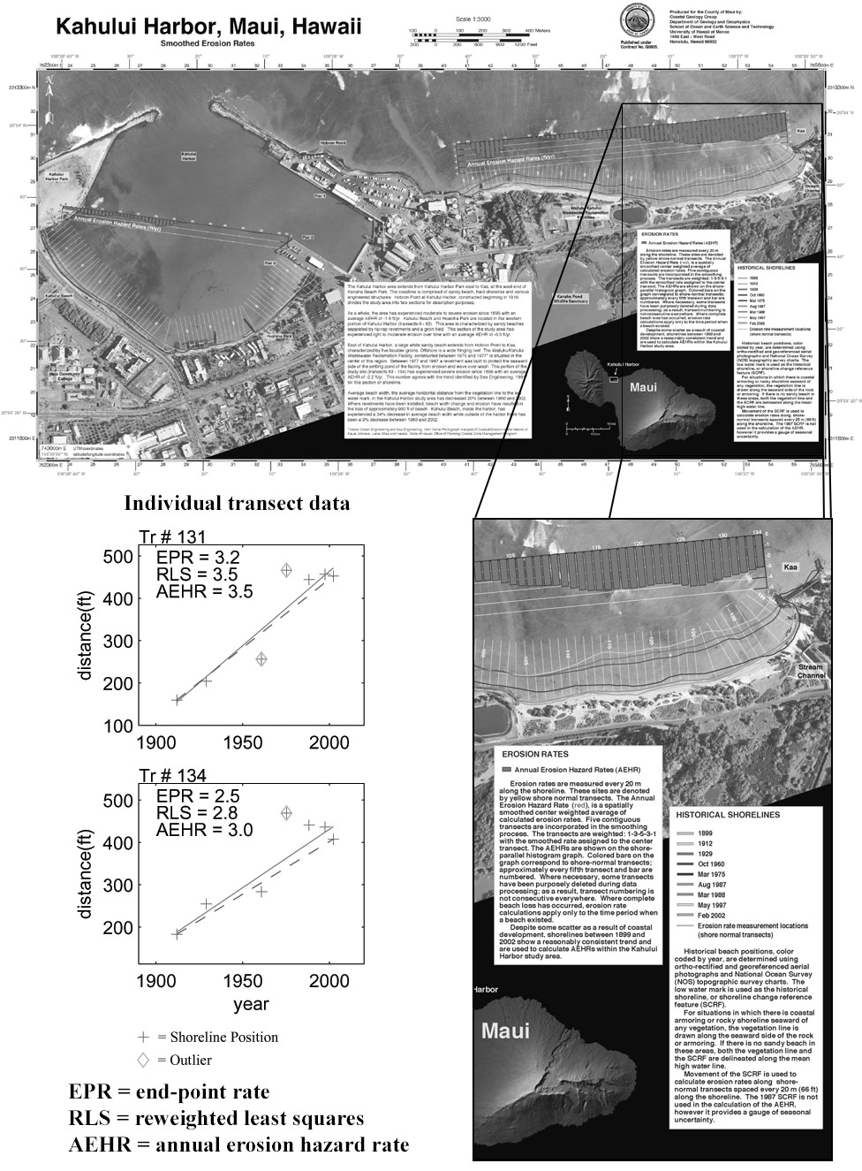

Figure 1. Annual erosion hazard map for Kahului, Maui. Shoreline position and regression data are shown for two individual transects. Each transect is analyzed using three different methods, as listed. The annual erosion hazard rate method is used for setback determination.
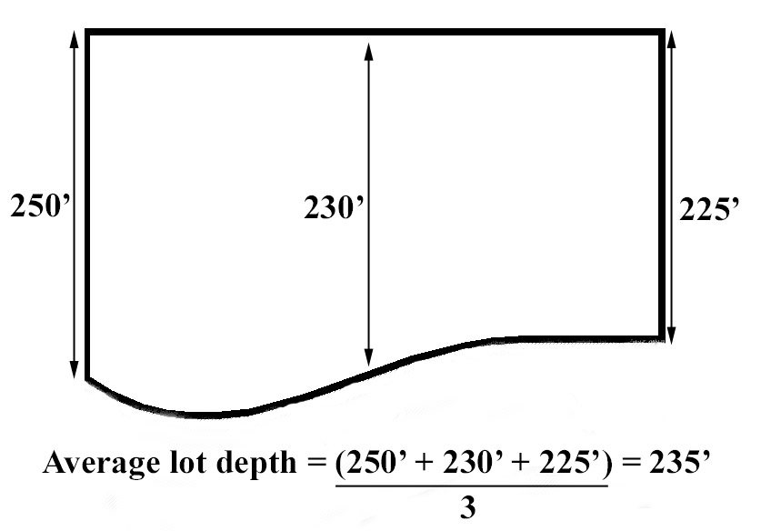

Figure 2. Average lot depth is determined by dividing the sum of the lot depth at both sides and the center of the property, by three.

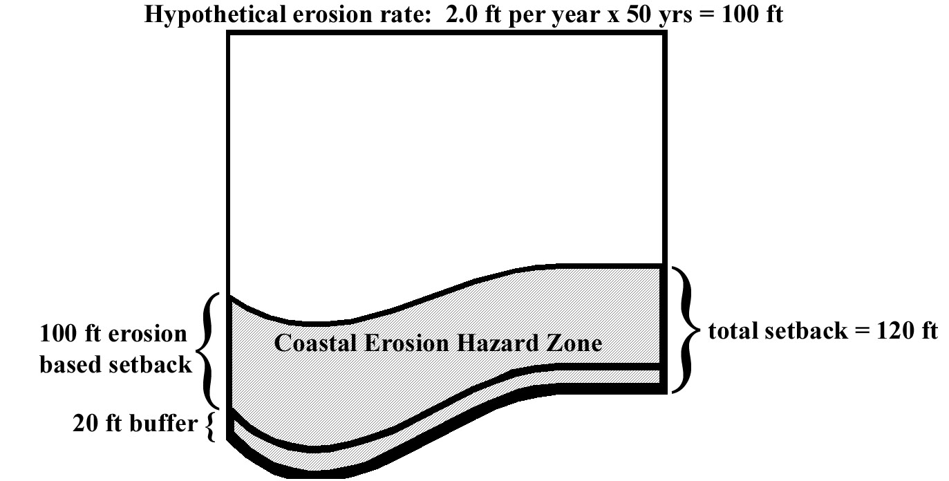

Figure 3. Erosion rate based setback calculation consists of 50 x the annual erosion hazard rate plus a 20 ft buffer.

Maui’s new construction setback calculation
The spacing of the transects for shoreline change calculations at 20 m intervals was chosen based on average property widths. With 20 m spacing, most properties have their own erosion rate. Initially, there were locations where the rates between adjacent properties varied significantly. To address this variability, the erosion rates on the final maps were smoothed with a 1-3-5-3-1 weighted running average.

The use a 50-year multiplier for the erosion hazard calculation was based on the minimum standard recommended by the Federal Emergency Management Agency (FEMA) Coastal Construction Guidebook (FEMA, 2000). A 70-year multiplier had been considered, but concern that too many lots would become unbuildable led to the decision to use the FEMA minimum standard. A 20 foot buffer is added to all erosion rate calculations in establishing the setback location so that in 50 years time, the shoreline should theoretically be 20 feet away from the dwelling rather than undermining the dwelling

For properties with more than one erosion rate transect, the setback line is determined by calculating the setback distance at each transect location and connecting the dots (Figure 4). For properties with small or negligible erosion rates, the former lot depth-based setback calculation method may yield a greater setback; for this reason, the new rules require that both the lot depth and erosion rate setback calculations be performed, and the greater of the two setback calculations is applied.
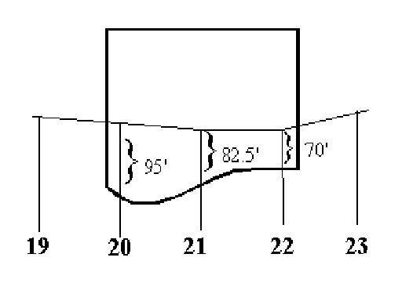
Figure 4. Setback determination example for property spanning multiple transects. Erosion rates of 1.5 ft/yr, 1.25 ft/yr and 1.0 ft/yr at transects 20, 21 and 22 respectively lead to setbacks of 95’, 82.5’ and 70’ respectively, which are connected to form the setback line.

For rocky shorelines, permitted seawalls and accreting sandy shorelines, the erosion rate equals zero. For formerly sandy shorelines that became rocky naturally by erosion or were artificially hardened by seawalls, erosion rates are still displayed on the maps and represent the erosion rate for the period of time in which the shoreline was sandy. For seawalls that are not legal, the erosion rate-based setback still applies. For legal seawalls or rocky shorelines, the erosion rate becomes zero and the lot depth-based setback calculation is used.

Due to the occurrence of small lot depths and/or high rates of erosion, instances exist where erosion rate-based setbacks render properties unbuildable. Thus, a 35 foot minimum buildable depth was established. The minimum buildable depth measurement begins at the front yard setback and extends seaward a maximum of 35 feet (Figure 5); however, at no time may the shoreline setback be less than 25 feet.

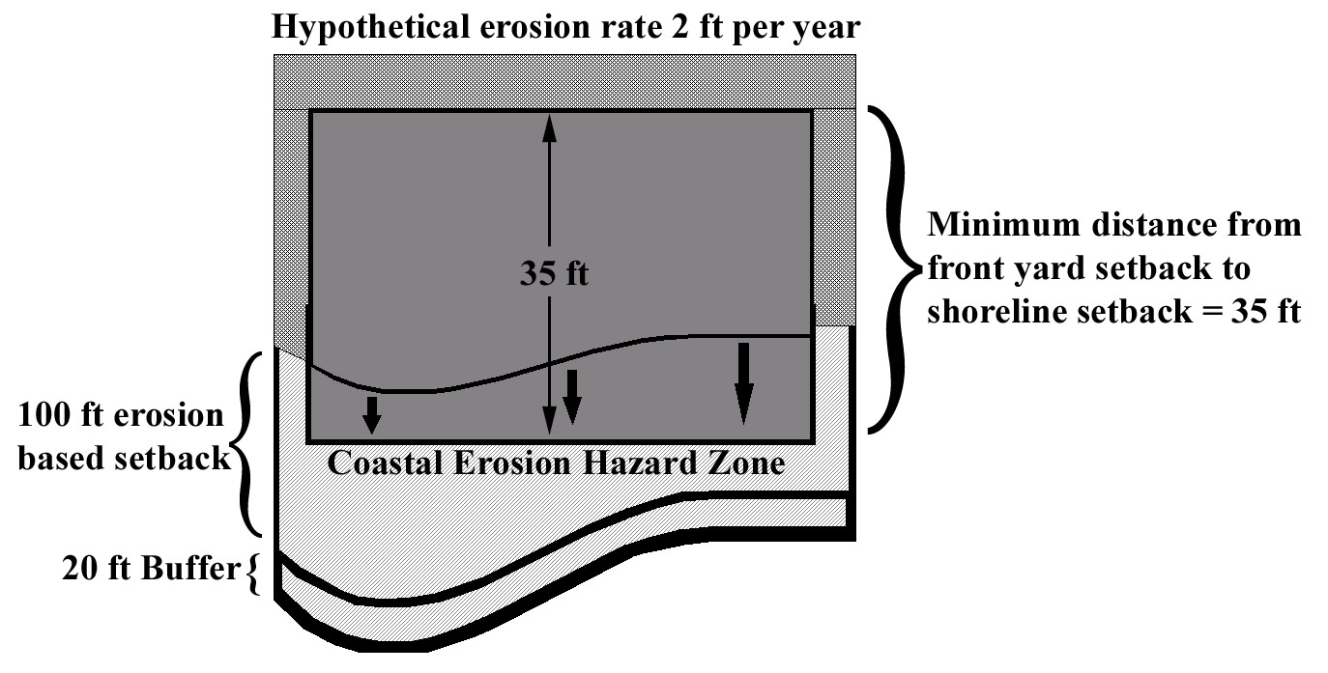
Figure 5. A minimum buildable depth of 35 feet was established to address the issue of “unbuildable” properties.

Issues raised by the public
At the first major public hearing in December 2002, approximately 100 members of the public presented testimony. The majority were coastal property owners opposed to the new rules due to the potential that the new rules would limit the use of or devalue their property. Most had not read the proposed rules, but had been alerted by neighbors of the potential changes. Many of their criticisms were unfounded and reactionary, but several important issues were raised. The main issues raised were then addressed prior to the second major public hearing in October 2003.

Lack of notification
Despite newspaper notification, radio broadcasts, the formation of an advisory committee and workshops with community groups, one of the main complaints from the individuals who testified at the 2002 hearing was that there had not been enough public notification regarding the proposed rule changes. Following the 2002 hearing, information about the proposed changes was mailed out with the water bills for every property on Maui, and a separate brochure was sent to every shoreline property owner. Additional meetings were held with realtors associations, taxpayers associations, local environmental groups, contractors associations, hotel associations, and homeowners associations.

Shoreline change methodology
Many coastal property owners seeing the erosion rate maps for the first time were surprised and alarmed to see the erosion rates. Consequently, they expressed concern regarding the methodology used by the University of Hawaii, wishing to ensure that the methods used were accurate and up to date. Many requested a second opinion or independent reviews of the methodology. Following the 2002 public hearing, the shoreline change study was reviewed by FEMA, the National Oceanic and Atmospheric Administration, the Hawaii Department of Land and Natural Resources, the United States Army Corps of Engineers, an the United States Geological survey. All agencies concurred that the methodology used was appropriate and among the best available.

Reconstruction following non-coastal damage such as fire
During the 2002 public hearing, several individuals raised the concern of being required to rebuild according to the new rules should their home be destroyed by fire. The question of arson being used as a means to require one’s neighbor to rebuild farther back from the shoreline was raised. While this scenario could be considered extreme, the decision was made following the hearing to allow homes destroyed by non-coastal-related hazards to be rebuilt on the original footprint.

Impacts on insurance rates and policies
One of the more challenging concerns to address was that of the potential effects on obtaining insurance policies, insurance rates, and general insurability of a home located in an erosion hazard zone. To address these concerns, provisions were incorporated into the rules whereby a nonconforming structure that is damaged by a non coastal-related means (for example a fire or an earthquake) may be rebuilt on the same footprint. For structures damaged by coastal hazards (for example wave damage, erosion, coastal flooding or a tsunami), a structure needing more than 50% repairs would need to be rebuilt in compliance with the new rules. However, this is also the case for the rules adopted in 1990; thus the new rules did not introduce a new variable. Further, the inclusion of the 35 foot minimum buildable depth clause ensured that no property would become unbuildable.

The setback rules notwithstanding, all repairs to dwellings in the shoreline area are still subject to other existing, discretionary laws such as the county’s Special Management Area rules, which do not guarantee repairing a structure in a coastal hazard area in the exact same manner and location as before its destruction. Thus, particularly with the provisions in the new rules mentioned in the previous paragraph, the new rules do not create additional obstacles to insurability of coastal properties.

Minimum buildable depth too restrictive
Concern was expressed during the 2002 public hearing that the minimum buildable depth of 35 feet was too small. On this issue, the Maui Planning Department took the position that 35 feet allows for a reasonably sized dwelling; for example, a 50 ft x 35 ft 2-story building would have 3000 square feet of floor space. Further, the department supported the setback of structures as far as possible from coastal hazards, and protecting the integrity of shoreline resources.

Implementation Issues
One of the fundamental challenges in developing the new rules was to find the balance between broad and specific guidelines that would best account for unforeseen circumstances. The implementation of the new setback rules has been relatively uncomplicated and has been met with considerable cooperation from shoreline permit applicants. However, individual cases periodically arise that have not been accounted for in the setback calculation methods provided by the rules. Currently these situations are being addressed on a case-by-case basis but it is clear that further clarification of the rules will be necessary. The following issues describe some of the unaddressed situations that have arisen.

Bluff erosion
While the new erosion based setback rules address the issue of erosion on sandy shorelines, the existing rules fail to address the issue of bluff erosion. Many of Maui’s shorelines consist of clay banks and bluffs which may erode rapidly in response to impacts from waves and ocean spray, as well as in response to groundwater increases from irrigation, sumps, water leaks and heavy rainfall. Currently, there are no restrictions on siting of structures on bluffs, nor is there a trigger for geotechnical surveys. Information regarding erosion of Hawaiian bluffs is limited. A local engineering firm calculated an average bluff retreat of 1 foot per year for a Maui property, based on previous shoreline certifications that delineated the bluff edge. Dwellings on a neighbor island that were built with approximately 40 foot setbacks from the bluff edge 40 years ago are now being undermined (Figure 6).

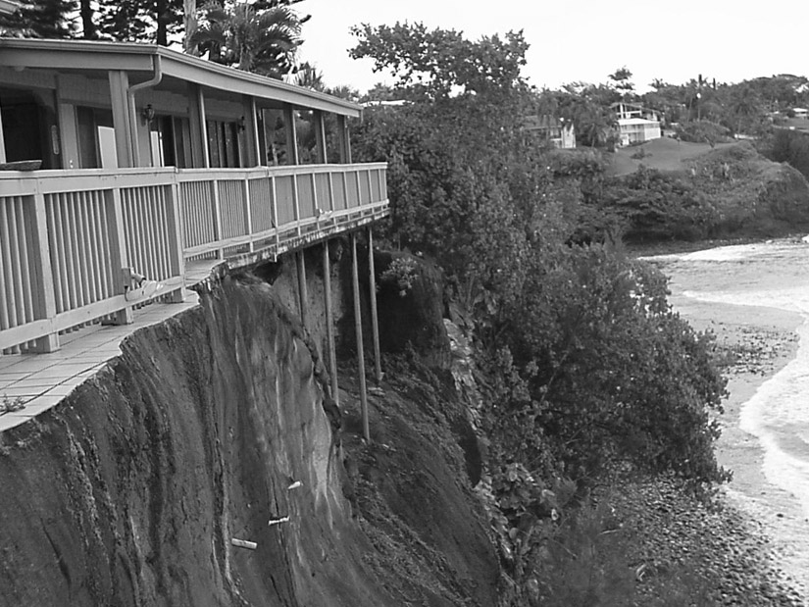

Figure 6. Bluff erosion on the island of Hawaii

Demolition
While the stated purpose of the new rules is to regulate development within the shoreline area, the concept of reducing intensity of use was not addressed. Thus, the demolition of existing structures including dwellings, seawalls, and revetments, requires the applicant to obtain a regulatory variance, which is a costly and time-consuming process. Consequently, applicants may be discouraged and choose instead to leave the structures in place. In such cases, a specific exemption for reduction of intensity of use, or discretionary authority to allow such an exemption, would be desirable.

Unusually-shaped parcels and shorelines
With parcels that are not rectangular, have more than one shoreline (peninsulas or spits), or only have a portion of the parcel abutting the shoreline (“L” or “flagpole lots”), setback calculation formulas must be modified. Without a provision in the rules for unusually shaped lots, property owners and planners are challenged with developing a calculation method that both parties agree upon. In such cases it would be desirable to have explicitly provided discretionary authority for decision-making by the regulatory agency, in the event that an agreement is not reached.

Conclusion
The adoption of erosion rate-based construction setbacks for the island of Maui has been a landmark achievement within the state of Hawaii. It is anticipated that the new setback requirements will be beneficial in decreasing the need for shore protection and decreasing the risk of damage to lives and property from coastal hazards. While there was initially considerable concern on behalf of coastal property owners regarding potential negative impacts on their property rights, public education by way of meetings and brochure distribution was able to alleviate many of these concerns. Following the successful implementation of the new setback rules, unforeseen cases have arisen that require special consideration and may warrant further amendments to the rules. Primarily, a provision that allows governing agencies the discretionary authority to make judgments on unforeseen situations based on the intent of the policy, would be desirable.

References
Federal Emergency Management Agency, 2000. Coastal Construction Manual: Principles and practices of Planning, Siting, Designing, Constructing, and Maintaining Residential Buildings in Coastal Areas. Volume I, P. 7-53.

Fletcher, C.H., Rooney, J., Narnee, M., Lim, S.-C., Richmond, B., 2004. Mapping shoreline change using digital orthophotogrammetry on Maui, HI. In Byrnes, M.R., Crowell, M., Fowler, C. (eds). Shoreline mapping and change analysis: Technical considerations and management implications. Journal of Coastal Research Special Issue #38, P. 106-124.

